

Fergusson College, Pune

Department of Statistics

T.Y. BSc Project 2020-21

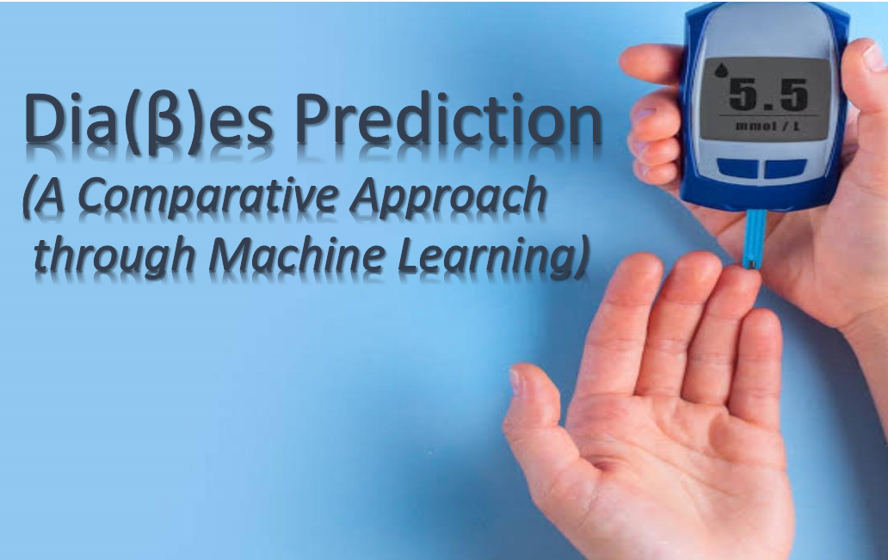

* **Project By:**

1. Srishti Batra-4507

2. Akhilesh Deshmukh-4510

3. Akshay Deshmukh-4511

4. Sumit Gawande-4521

5. Amisha Matkar-4540

6. Chandrahas Nhayade-4546

7. Pratiksha Patil-4551

8. Snehal Patil-4553

# ACKNOWLEDGEMENT

We would like to express special thanks of gratitude to our guide, Mr. Sheetal Gadekar Sir, for his valuable inputs and continued motivation. Sir lent us valuable books, referred us to some great papers, gave new perspectives and ideas and was always accessible for discussion and doubts. We are profoundly grateful for the support.

This project would have been impossible without Josh Stammer from “Stat Quest” and Krish Naik on You tube. Their tutorials on Machine Learning techniques helped us to clear our basics, enabling us to take up this project. Also, a big thanks to Stack Exchange and Cross Validated online communities.

We are thankful to the Statistics Department, Fergusson College, for giving us this opportunity. This project truly helped us to apply statistics in real life, we have learnt much more than we ever imagine.

At starting, in this situation it was difficult for us to communicate with each other and discuss things due to online mode of communication, but it became easier and interesting by doing this project.

**INDEX**

|  |  |
| --- | --- |
| **Sr. No** | **Topics** |
| 1. | Introduction |
| 2. | Motivation |
| 3. | Abstract |
| 4. | Keywords |
| 5. | Objectives |
| 6. | Data Set |
| 7. | Exploratory Analysis |
| 8. | Classification Models |
| a. | Logistic Regression |
| b. | KNN |
| c. | Random Forest |
| d. | Classification and regression trees |
| e. | Naïve Bayes |
| 9. | Comparison |
| 10. | Conclusion |
| 11. | Scope |
| 12. | Limitations |
| 13. | References |

**INTRODUCTION:**

Diabetes is a disease which stays with the patient life-long except in some cases where the diabetes is gestational which occurs during pregnancy and often goes back to normal after the delivery. Typically, there are three types of diabetes. The management of diabetes mostly depend on patient himself or herself because in diabetes it is all about self-care. But of course, the guidance comes from the nurse and doctors and they need to educate the patients in order to control their condition. In order to prevent (in cases where there are chances of diabetes occurrence) or control (in cases where the person already have diabetes) it is very essential to take care of patient’s weight, blood pressure, blood sugar and blood lipids.

**Types of diabetes: -**

There are three main types of diabetes:

**Type-I** diabetes used to be called juvenile-onset diabetes or insulin dependent diabetes. It is usually caused by an auto-immune reaction where the body’s defence system attacks the cells that produce insulin. People with Type-I diabetes produce little or no insulin. The disease may affect people of any age, but usually develops in children or young adults. People with this form of diabetes need injections of insulin every day in order to control the levels of glucose in their blood. If people with Type-I diabetes do not have access to insulin, they will die.

**Type-II** diabetes used to be called non-insulin dependent diabetes or adult-onset diabetes, and accounts for at least 90% of all cases of diabetes. It is characterized by insulin resistance and relative insulin deficiency, either or both of which may be present at the time diabetes is diagnosed. The diagnosis of type-II diabetes can occur at any age. Type-II diabetes may remain undetected for many years and the diagnosis is often made when a complication appears, or a routine blood or urine glucose test is done. It is often, but not always, associated with overweight or obesity, which itself can cause insulin resistance and lead to high blood glucose levels. People with Type-II diabetes can often initially manage their condition through exercise and diet. However, over time most people will require oral drugs and or insulin.

Gestational diabetes (GDM) is a form of diabetes consisting of high blood glucose levels during pregnancy. It develops in one in 25 pregnancies worldwide and is associated with complications to both mother and baby. GDM usually disappears after pregnancy but women with GDM and their children are at an increased risk of developing Type-II diabetes later in life. Approximately half of women with a history of GDM go on to develop Type-II diabetes within five to ten years after delivery.

Table-1 shows the Normal Glucose Level chart.

**Table-1: Normal Glucose Level**

|  |  |  |
| --- | --- | --- |
| **Blood sugar classification** | **Fasting Blood Sugar Levels** | **Post Meal**  **Blood Sugar Level** |
| Normal | 70-100 mg/dl | 70-140 mg/dl |
| Pre-Diabetes | 101-125 mg/dl | 141-200 mg/dl |
| Diabetes | 125 mg/dl and above | 200 mg/dl and above |

**Machine Learning:**

In today’s world we just want to make the computers more intelligent. Since the most basic requirement of intelligence is learning, hence came the subfield of AI that is called machine learning (ML). ML is one of the most rapidly evolving fields of AI, which is used in many areas of life, primarily in the healthcare field. ML has a great value in the healthcare field since it is an intelligent tool to analyze data, and the medical field is rich with data. In the past few years, numerous amounts of data were collected and stored because of the digital revolution. Monitoring and other data collection devices are available in modern hospitals and are being used every day, and abundant amount of data are being gathered. It is extremely hard or even impossible for humans to derive useful information from this massive amount of data. Hence machine learning is becoming increasingly popular to analyze such data and diagnose problems in the healthcare field. A simplified explanation of what the machine learning algorithms would do is, it will learn from previously diagnosed cases of patients. The resulting classifier can have many uses such as helping doctors to diagnosis new patients with higher speed and efficiency and training students and non-specialists to diagnose patients. Since we have vast number of medical datasets, machine learning can help us discover patterns and beneficial information from them. Although it has many uses, in the medical field, machine learning is mostly used for disease prediction. Many researchers became interested in using machine learning for diagnosing diseases because it helps to reduce diagnosing time and increases the accuracy and efficiency. Several diseases can be diagnosed using machine learning techniques, but the focus of this paper will be on heart disease diagnosis. Since heart disease is the primary cause of deaths in the world today, and the effective diagnosis of heart disease is immensely useful to save lives.

**Working of Models**

**Collecting the data:**

It involves the importation of data and useful libraries which we’re going to usethroughout the analyzation.

**Analysing the data:**

This step involves the analyzation and exploration of data variables, in our case, skin thickness, pregnancy, etc.

**Data wrangling:**

In this step, we remove the unnecessary contain such as null values in the data ofrespective variables. Basically, here we clear the data.

**Train and test:**

Here we build the model and perform a split which divides the data in trainingand testing dataset.

**Accuracy:**

Here we test how much accurate our values are and find the accuracy.

**Some definitions:**

**Confusion Matrix:**

A confusion matrix is a table that often used to describe the performance of a classification model (or “classifier”) on a set of test data for which the true values are known. The confusion matrix itself is relatively simple to understand, but the related terminology can be confusing.

**True positives (TP):**

These are the correctly predicted positive values which means the value of actual class is Yes and the value of predicted class is also Yes.

**True negatives (TN):**

These are correctly predicted negative values which means that the value of actual class is No, and the value of predicted class is also No.

**False Positives (FP):**

False positive is an error in binary classification in which a test result incorrectly indicates the presence of a condition such as a if the actual condition is false, but prediction tells it as True. It is also known as Type 1 error.

**False Negatives (FN):**False negative is the error in binary classification in which a test result incorrectly fails to indicate the presence of the condition when it is present which means the actual class is Yes, but the predicted class is No.

**Accuracy:**

Accuracy is the most intuitive performance measure, and it is simply a ratio of correctly predicted observations to total observations.

|  |
| --- |
| **Accuracy = (TP+FN)/(TP+FP+FN+TN)** |

**Precision:**

Precision tells us that how many of the correctly predicted cases turned out to be positive.

|  |
| --- |
| **Precision = (TP)/(TP+FP)** |

**Sensitivity (Recall):**

It tells us that how many of the actual positive cases we were able to predict correctly with our model.

|  |
| --- |
| **Sensitivity = TP/(TP+FN) =>True Positive Rate (TPR)** |

**F1 Score:**

F1 score is the weighted average of precision and recall. Therefore, this score takes both false positives and false negatives into account.

|  |
| --- |
| **F1 Score = 2(Recall * Precision)/(precison+recall)**  **=TP/((TP+(FP+FN)/2)** |

**ROC-AUC Curve**

In Machine Learning, performance measurement is an essential task. So, when it comes to a classification problem, we can count on an AUC - ROC Curve. When we need to check or visualize the performance of the multi-class classification problem, we use the AUC (**Area Under the Curve**) ROC (**Receiver Operating Characteristics**) curve. It is one of the most important evaluation metrics for checking any classification model’s performance. It is also written as AUROC (**Area Under the** **Receiver Operating Characteristics**).

# What is the AUC - ROC Curve?

AUC - ROC curve is a performance measurement for the classification problems at various threshold settings. ROC is a probability curve and AUC represent thedegree or measure of separability. It tells how much the model is capable of distinguishing between classes. Higher the AUC, the better the model is at predicting 0s as 0s and 1s as 1s. By analogy, the Higher the AUC, the better the model is at distinguishing between patients with the disease and no disease.

The ROC curve is plotted with TPR against the FPR where TPR is on the y-axis and FPR is on the x-axis.

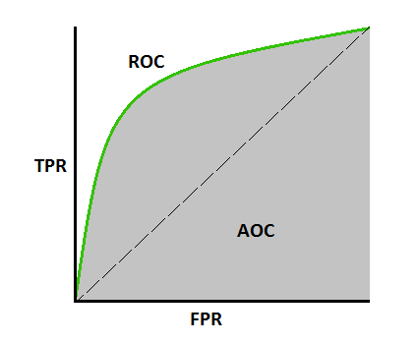

# ****How to speculate about the performance of How the model?****

An excellent model has AUC near to the 1 which means it has a good measure of separability. A poor model has AUC near to the 0 which means it has the worst measure of separability. In fact, it means it is reciprocating the result. It is predicting 0s as 1s and 1s as 0s. And when AUC is 0.5, it means the model has no class separation capacity whatsoever.

**MOTIVATION:**

Diabetes is a chronic condition in which the body develops a resistance to insulin, a hormone which converts food into Glucose. Approximately 247 million people all over the world have been diagnosed with diabetes. There is an increased risk for people with an increase in central obesity for heart disease and diabetes. Increased caution is required for lean people with type 2 diabetes at every age, as type 1 diabetes can occur in older people and with slower onset than is normally seen in the young.

As per International Diabetes Federation (IDF), India is one of the participants with more diabetic people. It is reported that about 72 million people are affected by diabetes in 2017-18. Though the diabetes is not fatal, it is not curable, and the ill-effects continue till the lifetime of patient. Hence, it is better to predict rather than treat the disease. There are three types of diabetes. When patient is affected by diabetes of type 1, then the insulin is not secreted by the body such that patient must inject insulin to the body. In case of type 2 diabetes, the body develops resistivity against insulin and insulin is not exploited in usual way. The type 3 diabetes occurs due to excessive blood glucose levels.

Hence, it is highly appreciable when diabetes is predicted in advance. As students of statistics, we can work with any kind of data. Taking advantage of this, we decided to do this project in order to predict if a particular observation is at a risk of developing diabetes, given the independent factors.

We wanted to use emerging techniques to model this data, and in the process demystify all the buzzwords that have cropped up in recent times- data science, machine learning, analytics, intelligence as well as more accurate ones such as Random forests.

# ABSTRACT

In this project we attempt to predict diabetes in patients by using different statistical models such as Logistic regression, KNN, Random Forest, XG BOOST and R part classification. There are 9 predictor variables used in this classification including pregnancies (no of times pregnant), glucose, blood pressure, skin thickness, BMI, insulin, age, diabetes-pedigree, outcome. The 5 models are compared using metrics such as sensitivity, specificity and AUC. In the process we obtain their confusion matrices and ROC curves. Our aim is to find the model which is best suited for predicting this data. Exploratory analysis has also been

done to get a feel for the data and to detect any obvious relationships that might exist.

# KEYWORDS

Statistical learning, Confusion matrix, Sensitivity, Specificity, Accuracy, ROC, AUC Logistic regression, KNN, Random forest, Naïve Bayes, R part classification and regression trees.

**OBJECTIVES:**

The main objective of our project is to build a machine learning model to accurately predict whether the patients in the dataset have diabetes or not.

We will build and train following machine leaning models during this analysis.

1. Naïve Bayes
2. K-Nearest Neighbours
3. Random Forest
4. Logistic Regression
5. R part classification and regression trees

# DATA SET

The data set is comprised of 768 observations and 9 variables such as pregnancies, glucose, blood pressure, triceps, insulin, mass, pedigree, age and diabetes (outcome). We will use diabetes as our response or target variable. This dataset is originally from the National Institute of Diabetes and Digestive and Kidney Diseases. The objective of the dataset is to diagnostically predict whether a patient has diabetes, based on certain diagnostic measurements included in the dataset. Several constraints were placed on the selection of these instances from a larger database. All patients here are females at least 21 years old of Pima Indian heritage.

**Data description for the 9 variables is as follows,**

|  |  |  |  |
| --- | --- | --- | --- |
| **Sr.No** | **ATTRIBUTES** | **MEANING** | **DATA TYPE** |
| 1. | Pregnant | The total count of pregnancies encountered by the candidate. | Numeric |
| 2. | Glucose | The glucose concentration is measured by means of oral glucose tolerance test. | Numeric |
| 3. | Pressure | The diastolic blood pressure encountered by the arteries during the pause time between the heart beats (mm Hg). | Numeric |
| 4. | Triceps | The thickness of skin measured by considering the subcutaneous fats (mm). | Numeric |
| 5. | Insulin | The insulin serum is considered for 2 hours (mu/ml). | Numeric |
| 6. | Mass | The BMI considering both height in (m^2) and weight in (kg) of patient. | Numeric |
| 7. | Pedigree | This attribute considers the diabetes disease history with respect to the blood relations. | Numeric |
| 8. | Age | The age of patient. | Numeric |
| 9. | Diabetes | Class variables (test for diabetes) | Numeric |

More information on this dataset can be read by accessing the website:

<http://math.furman.edu/~dcs/courses/math47/R/library/r>

**EXPLORATORY WORK**

**PIE CHART**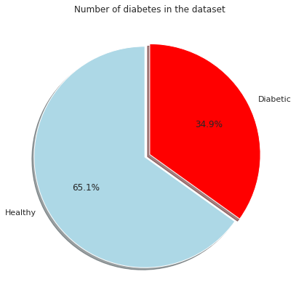

**From above pie chart, we can say that around 65% of the people are Healthy and 35% are Diabetic.**

DISTRIBUTION PLOTS

### **Healthy vs Diabetic by Pregnancy**

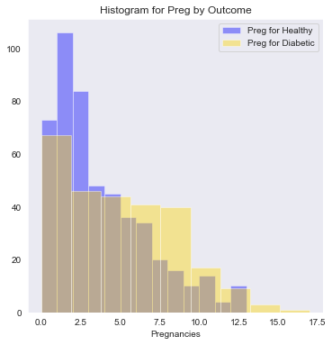

**From above graph, we can say that the Pregnancy isn't likely cause for diabetes as the distribution between the Healthy and Diabetic is almost same.**

**Healthy vs Diabetic by Glucose**

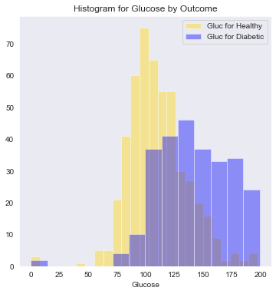

**Diabetes is a disease that occurs when your blood glucose, also called blood sugar, is too high. Blood glucose is your main source of energy and comes from the food you eat.**

**The Glucose level for a Normal Adult is around 120-130mg/dl anything above it means that the person is likely suffering from pre-diabetes and diabetes.**

**From above graph, we can see the Healthy person are more around 120mg/dl but it then gradually drops, and for diabetic person it is vice versa.**

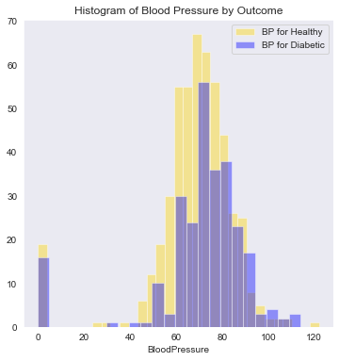Healthy vs Diabetic by Blood Pressure

**High blood pressure (also known as “hypertension”) is very common in people with diabetes. In fact, the two conditions often go hand-in-hand because they can both result from the same lifestyle factors.**

**Diabetes damages arteries and makes them targets for hardening, called atherosclerosis. That can cause high blood pressure, which if not treated, can lead to trouble including blood vessel damage, heart attack, and kidney failure. For a Normal person BP should be at or below 120/80 mm Hg, the person with hypertension can be above 139/89 mm Hg.**

**From above graph, we can say that diabetic and healthy people are evenly distributed with low and normal BP but, there are less healthy people who have high BP.**

**Healthy vs Diabetic by Skin Thickness**

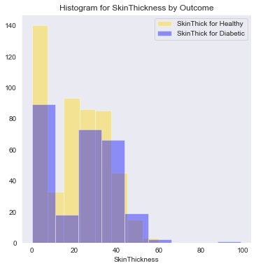

**Changes to the blood vessels because of diabetes can cause a skin condition called diabetic dermopathy. Dermopathy appears as scaly patches that are light brown or red, often on the front of the legs. The patches do not hurt, blister, or itch, and treatment generally is not necessary.**

**From above graph, the distribution between healthy and diabetic people are around same for skin thickness.**

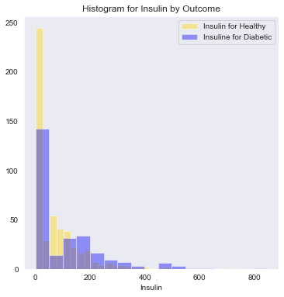**Healthy vs Diabetic by Insulin**

**Insulin is a hormone that your pancreas makes to allow cells to use glucose. When your body isn't making or using insulin correctly, you can take man-made insulin to help control your blood sugar. Many types can be used to treat diabetes.**

**Insulin helps control blood glucose levels by signalling the liver and muscle and fat cells to take in glucose from the blood. Insulin therefore helps cells to take in glucose to be used for energy. If the body has sufficient energy, insulin signals the liver to take up glucose and store it as glycogen.**

**From above graph, we can see that there are diabetic people increase as the levels of insulin gradually increases. There are more healthy people around insulin levels 0-100.**

**Healthy vs Diabetic by BMI**

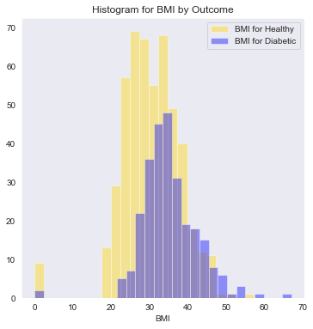

**Being overweight (BMI of 25-29.9),or affected by obesity (BMI of 30-39.9) or morbid obesity (BMI of 40 or greater), greatly increases your risk of developing type 2 diabetes. The more excess weight you have, the more resistant your muscle and tissue cells become to your own insulin hormone.**

**From above graph we can determine that, as the BMI increasesthe person likely being healthy decreases and being diabetic increases.**

**Healthy vs Diabetic by Diabetes Pedigree Function**

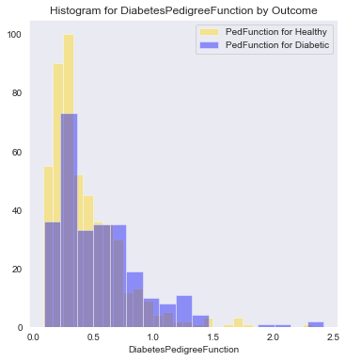

**Diabetes Pedigree Function is a function which scores likelihood of diabetes based on family history. It provided some data on diabetes mellitus history in relatives and the genetic relationship of those relatives to the patient.**

**From above graph, as the function increase the diabetic people increases, showing that the diabetes could be hereditary for that individual.**

**Healthy vs Diabetic by Age**

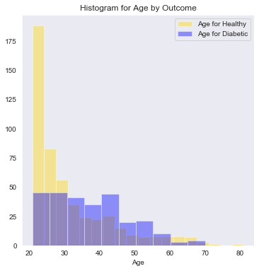

**As the person ages, they are at high risk for the development of type 2 diabetes due to the combined effects of increasing insulin resistance and impaired pancreatic islet function with aging.**

**From above graph, we can see that there are more healthy people around 20-25 age but as the age gradually increases so does the people being diabetic, this shows that age and diabetes go hand in hand.**

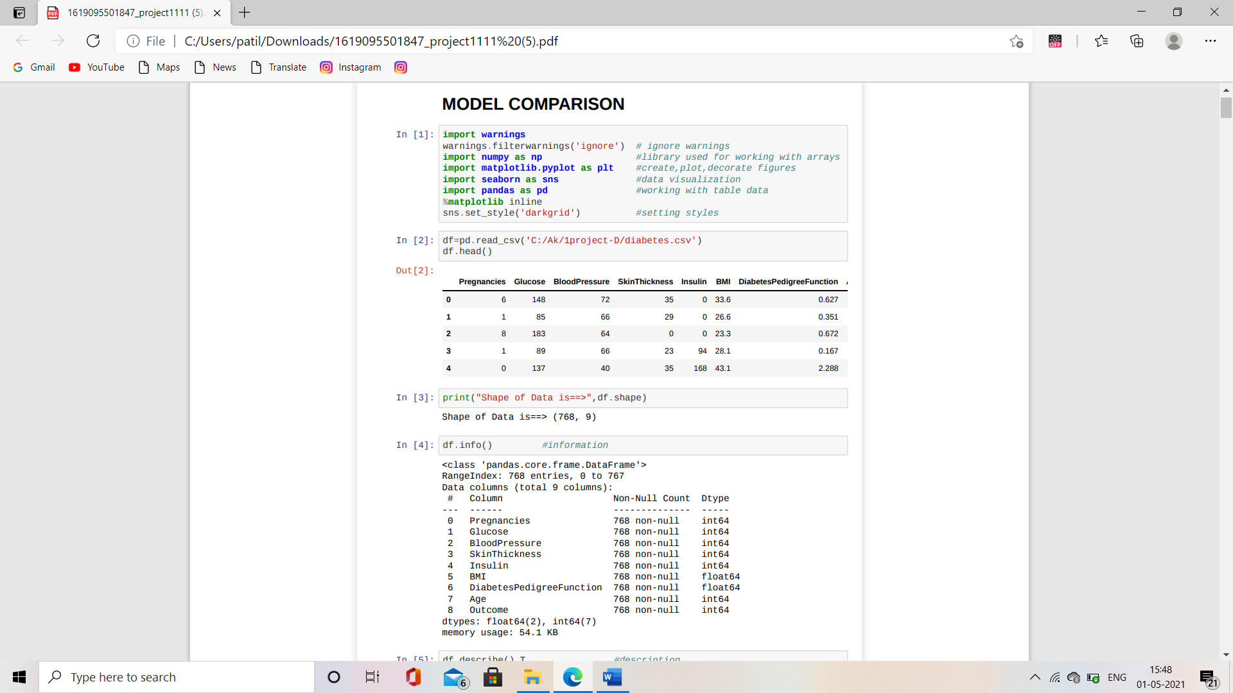

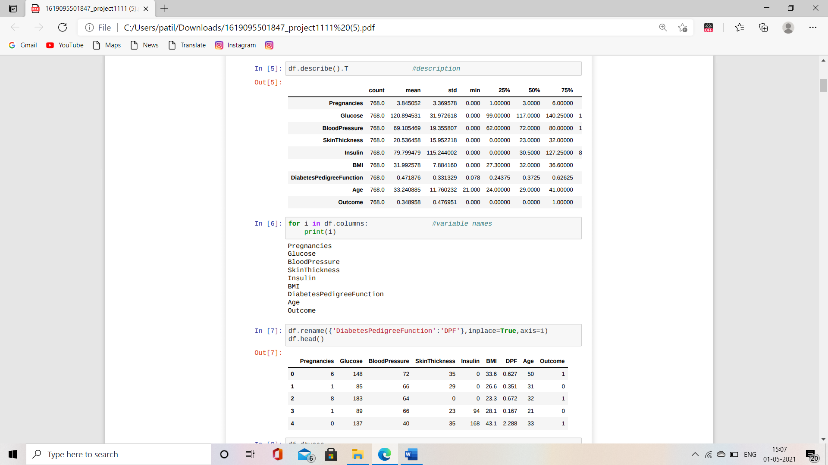

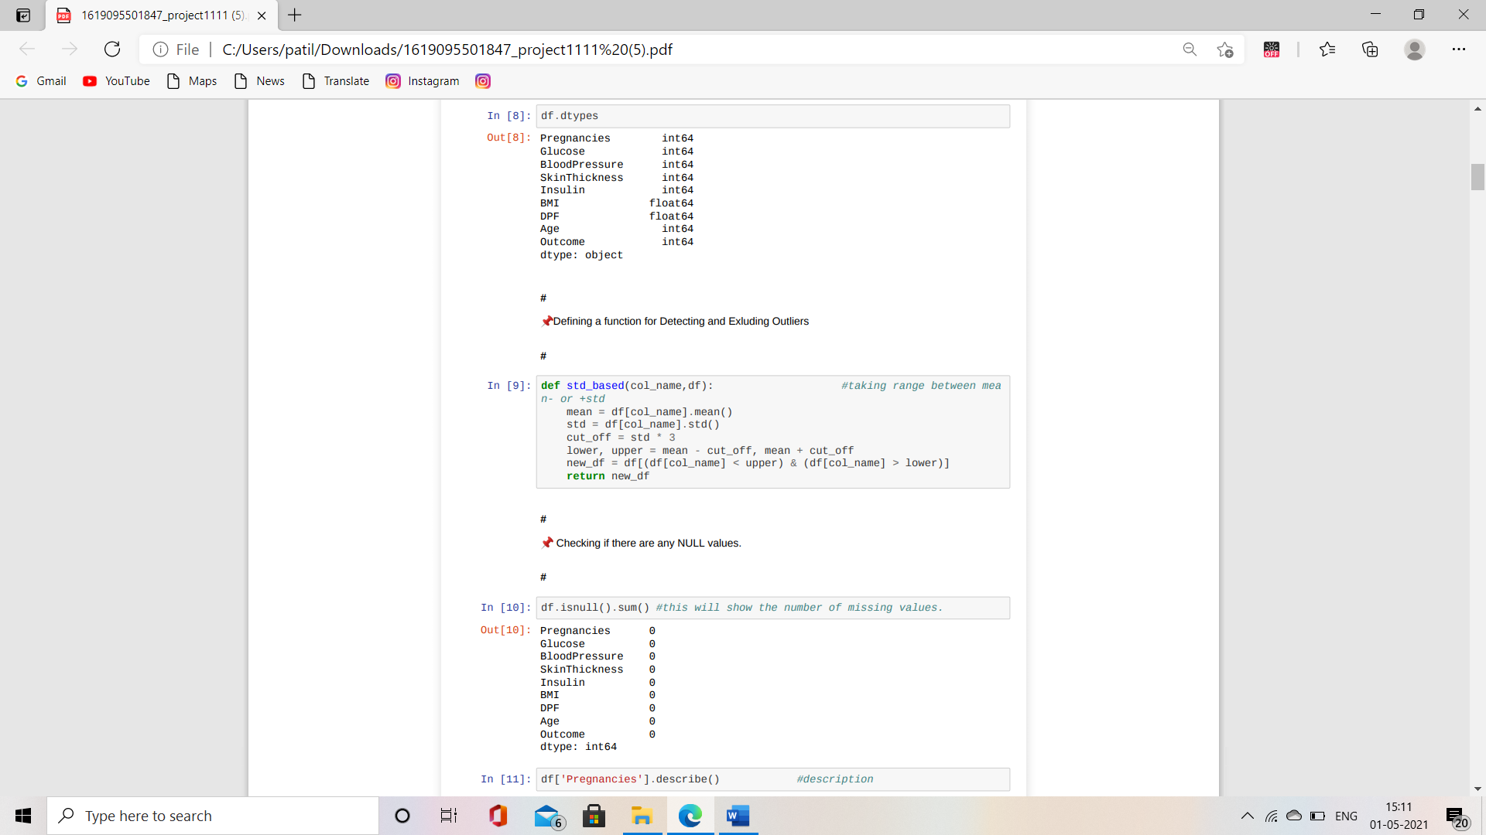

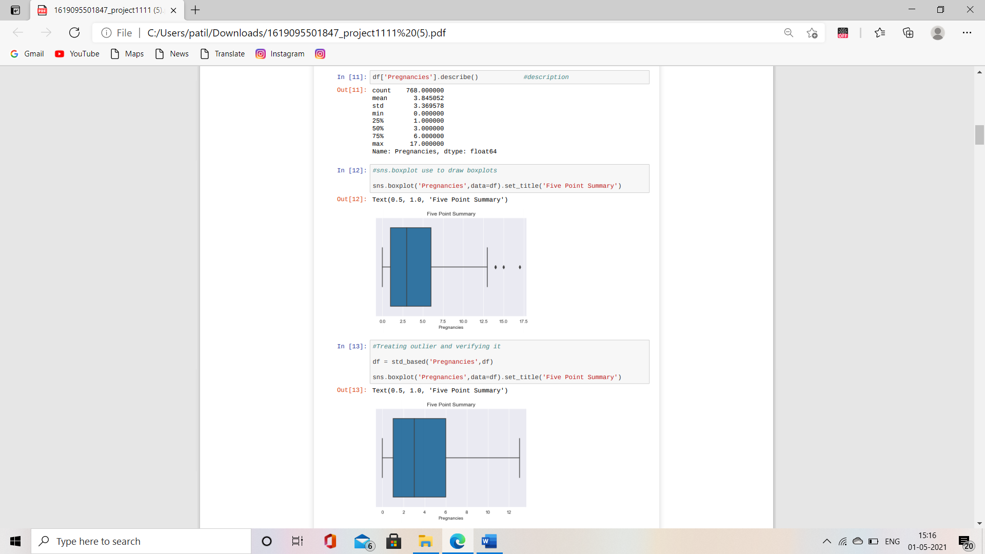

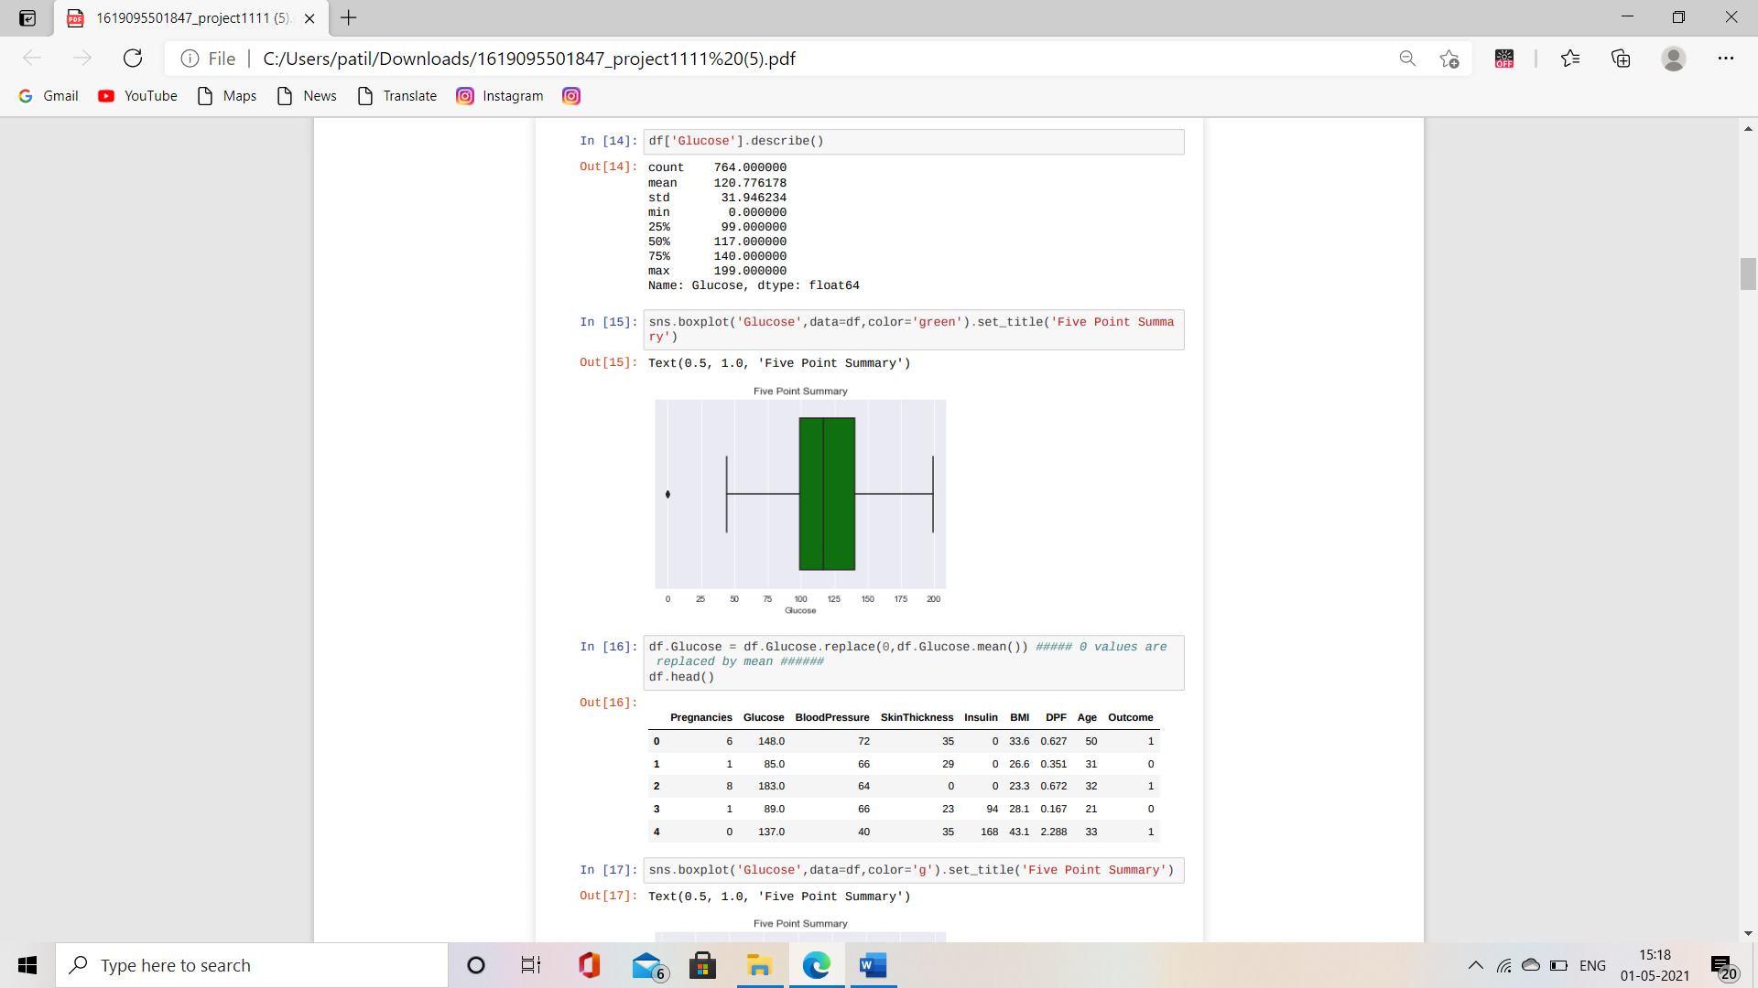

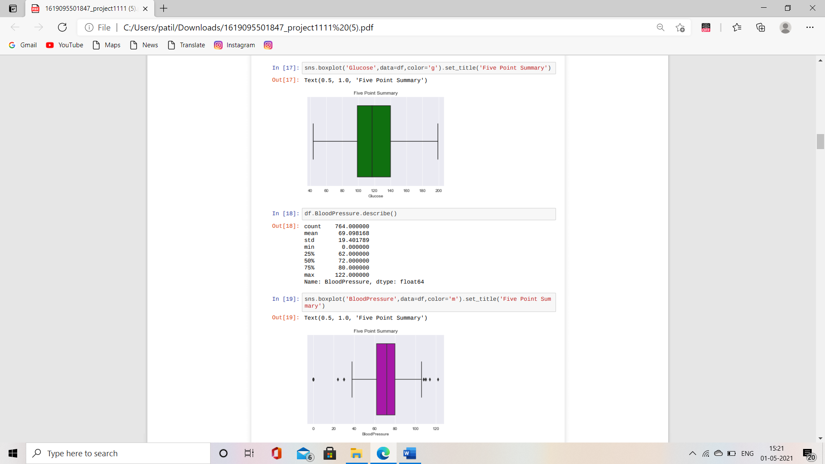

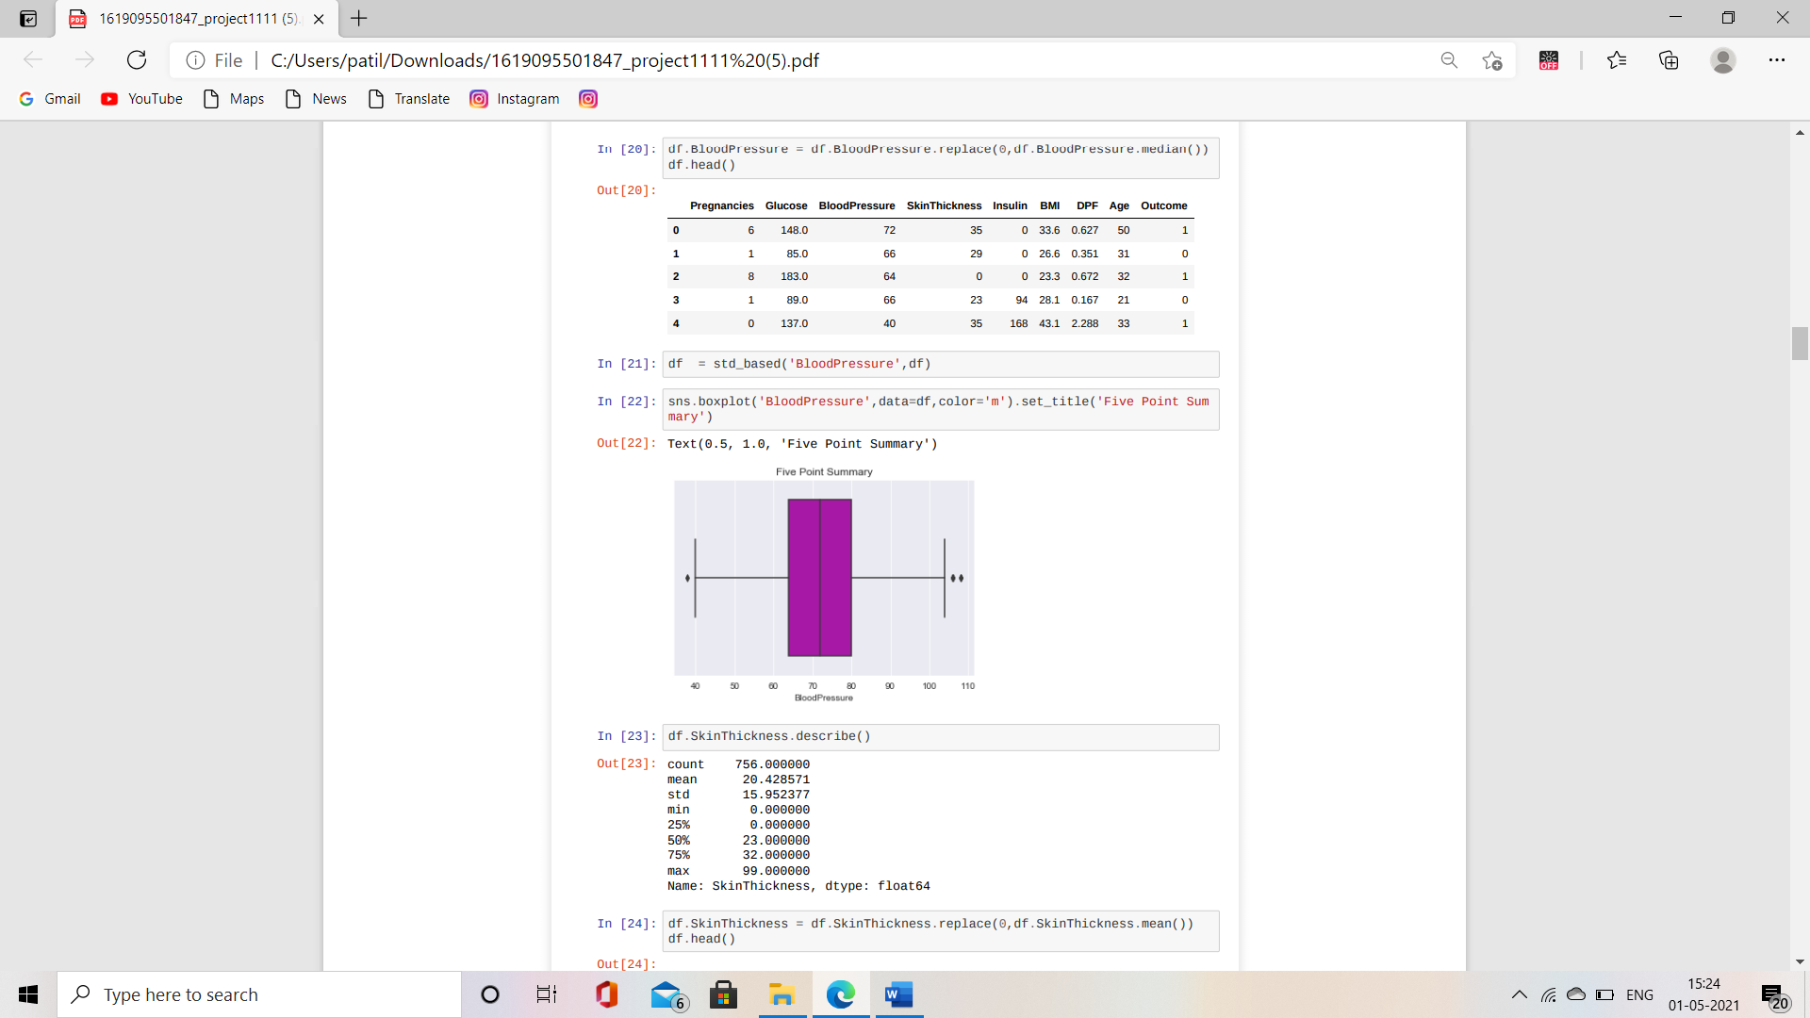

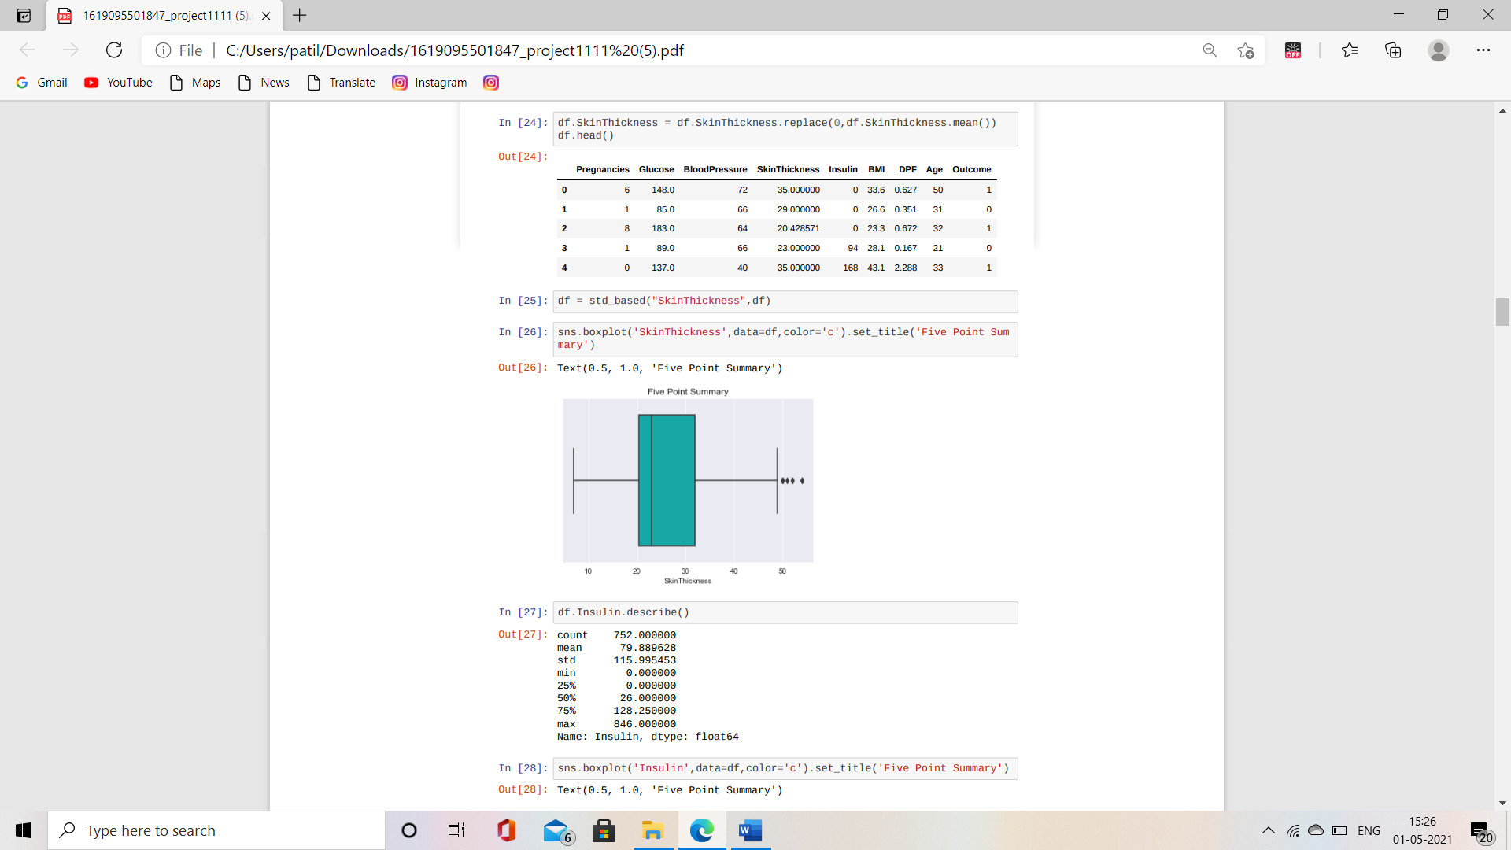

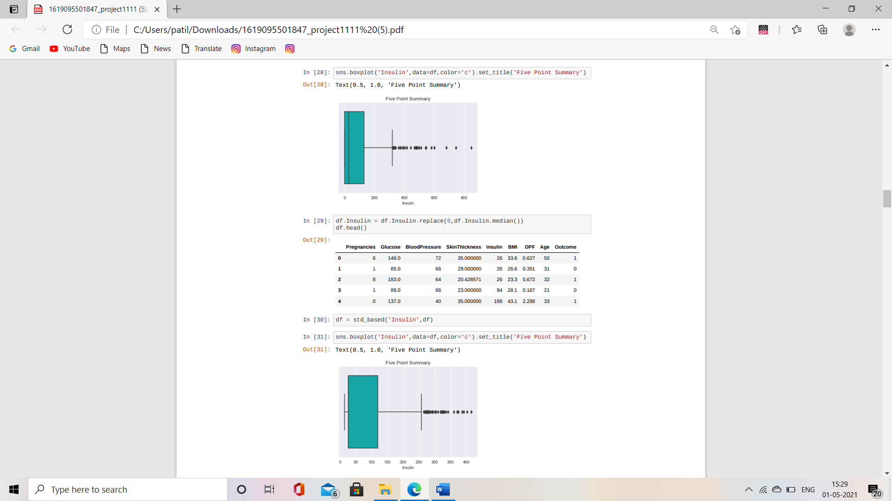

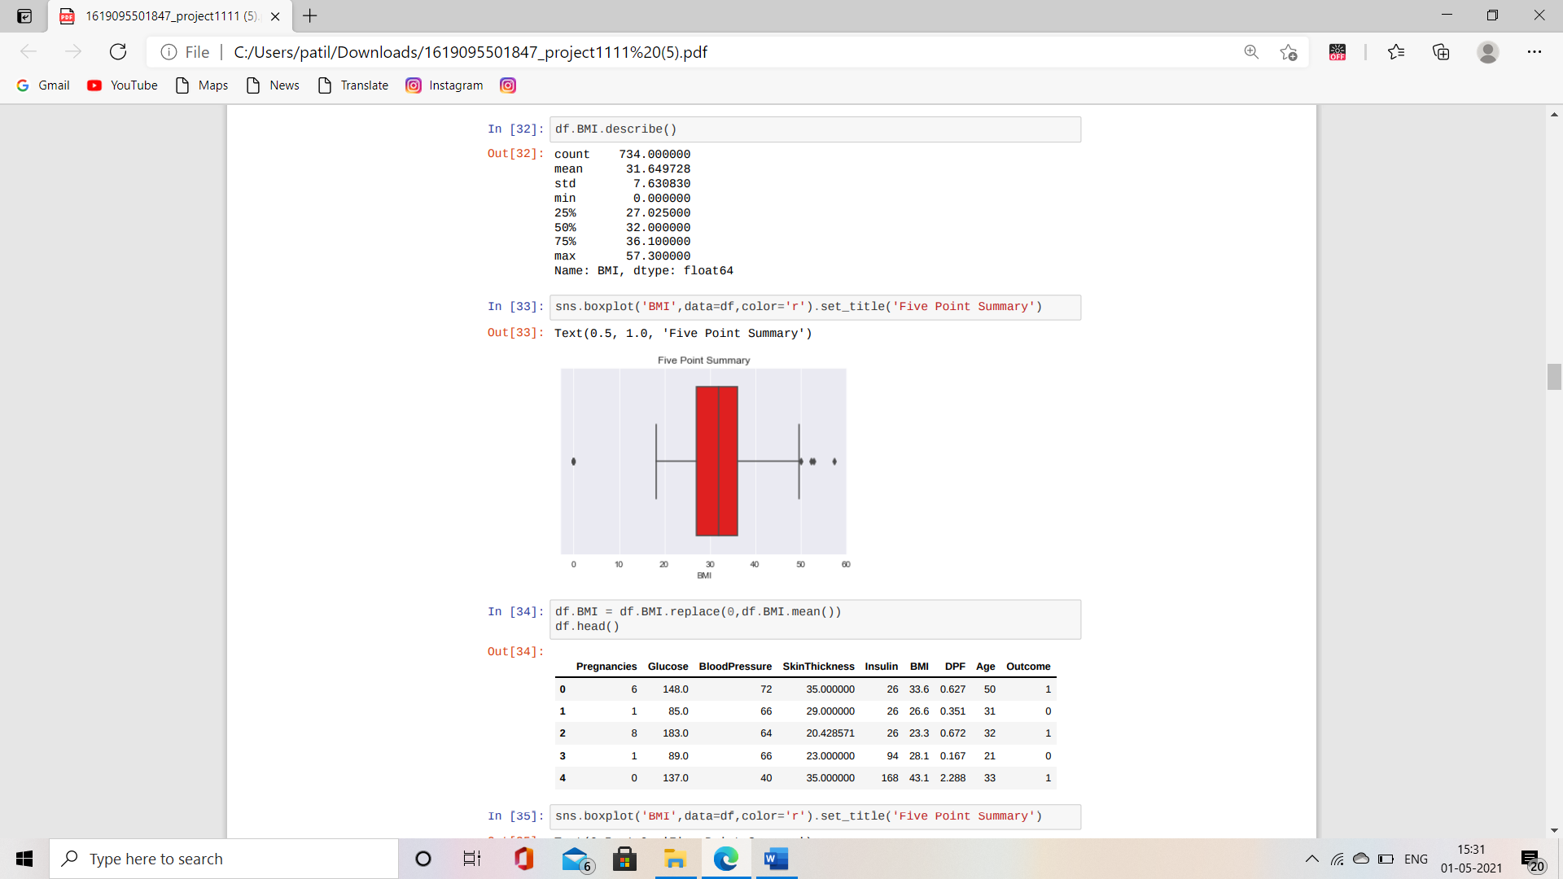

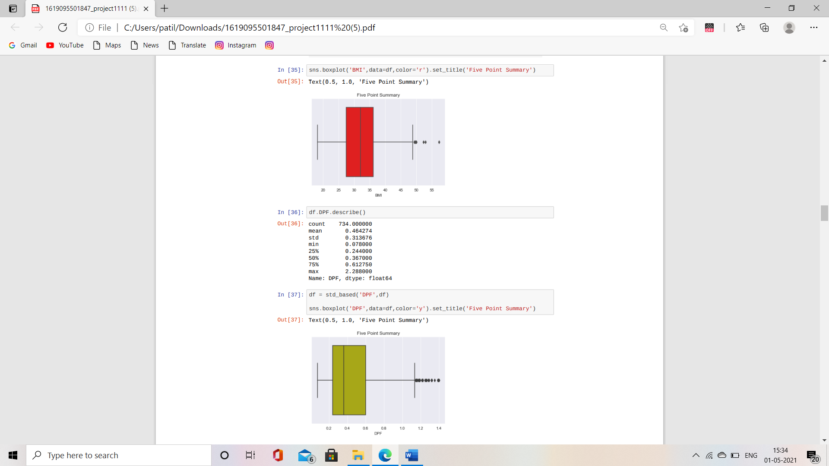

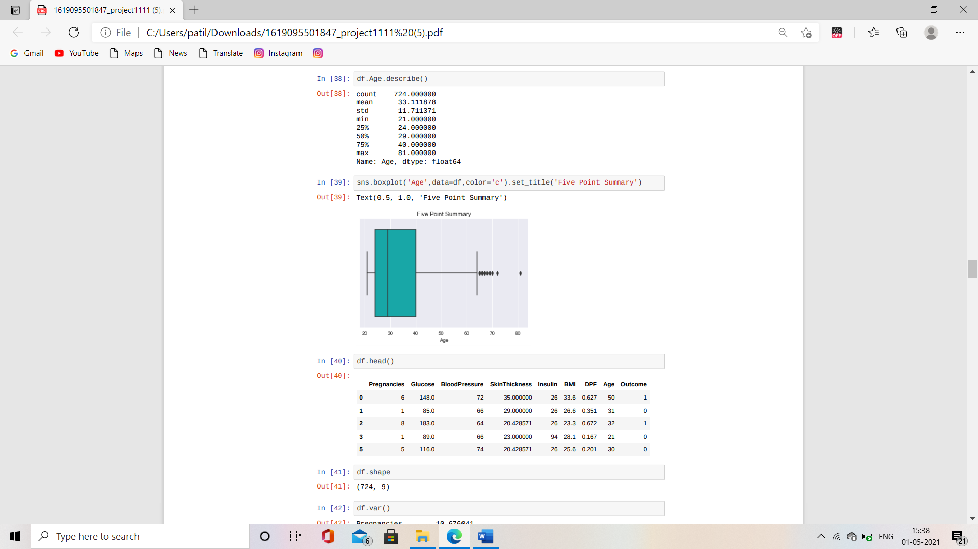

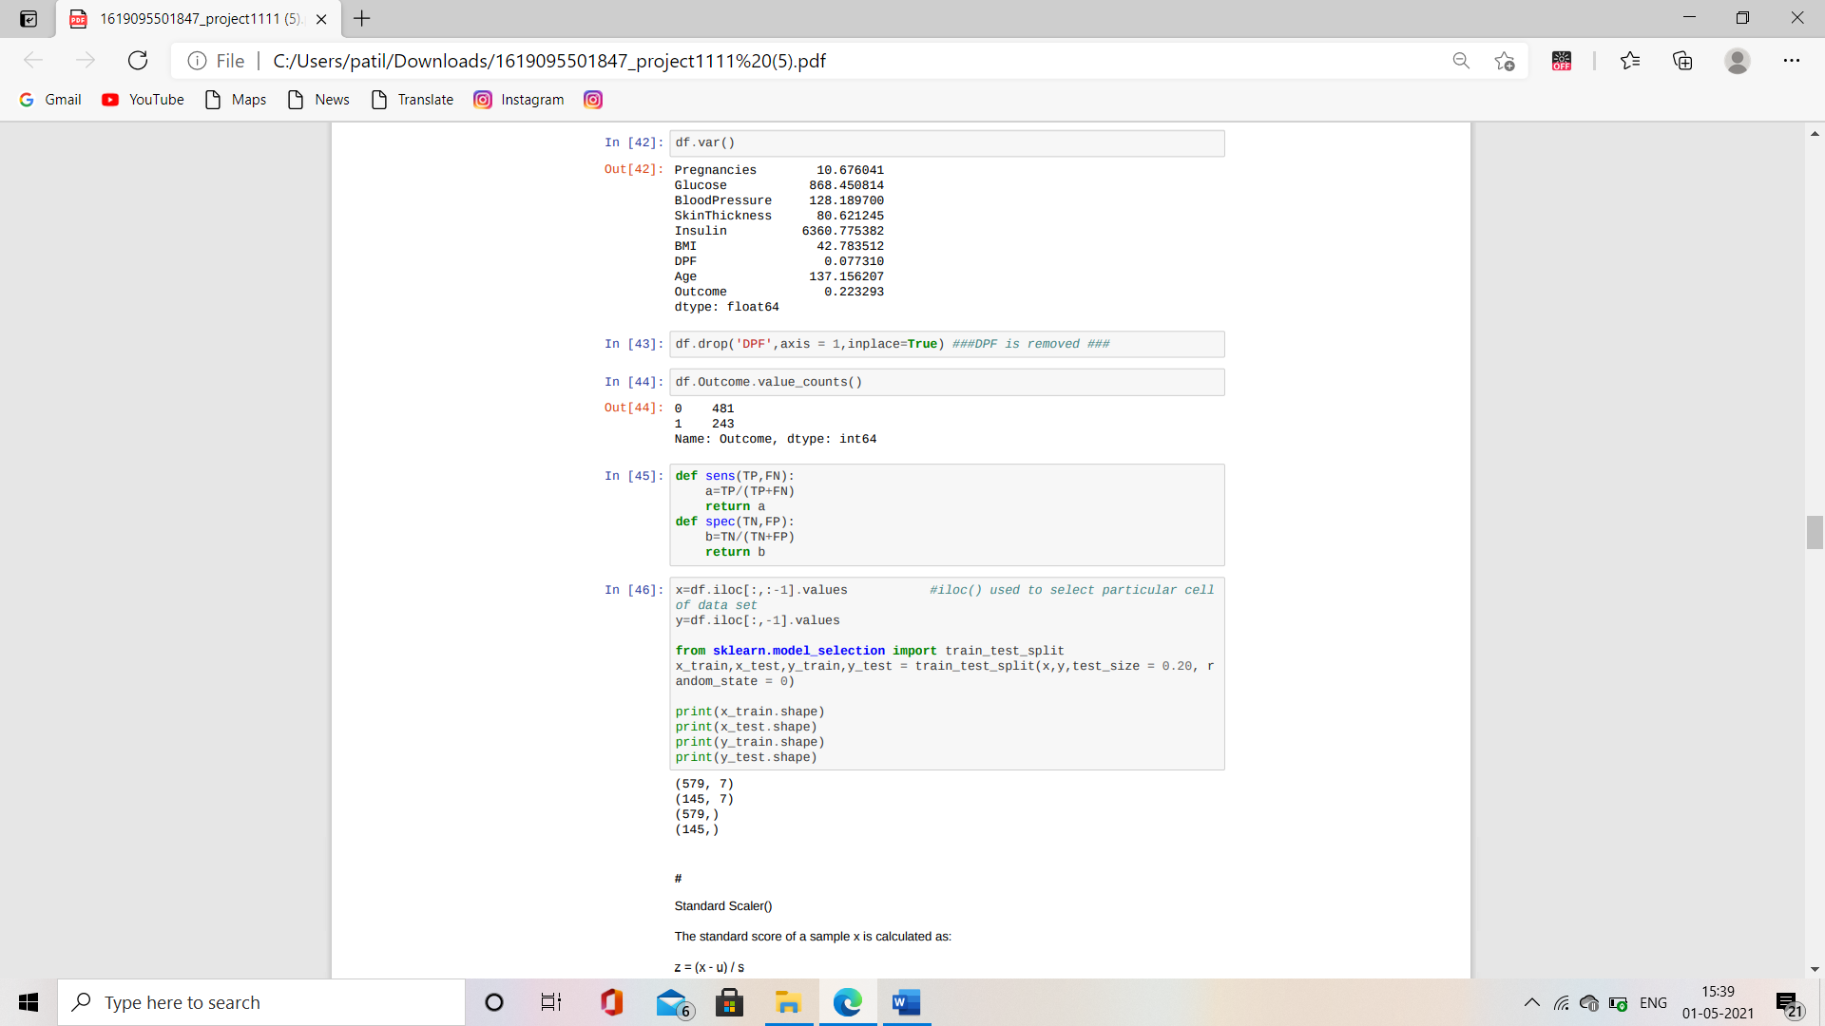

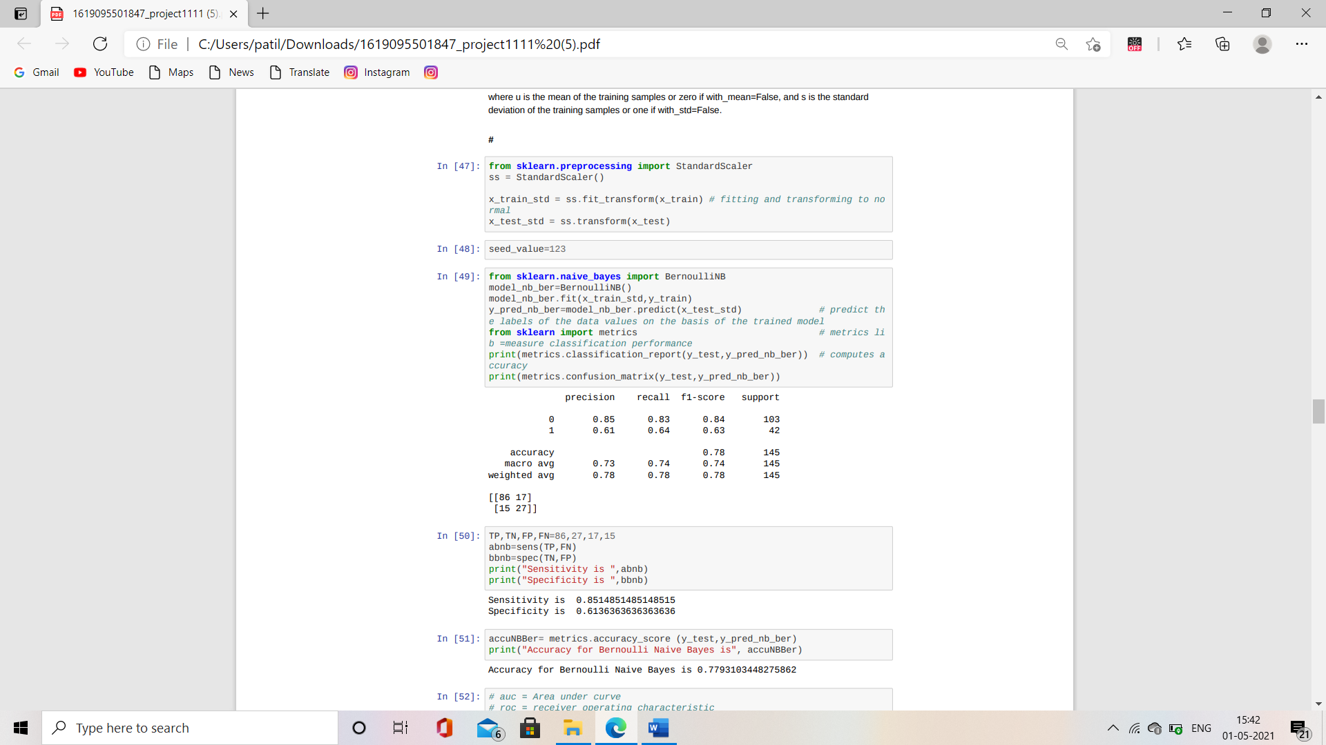

**Prediction of Diabetes Using Different Statistical Models:**

1. **Naive Bayes:**

**What is Naive Bayes algorithm?**

Naive Bayes classifiers are a collection of classification algorithms basedon Bayes’ Theorem. It is not a single algorithm but a family of algorithmswhere all of them share a common principle, i.e., every pair of features beingclassified is independent of each other In simple terms, a Naive Bayesclassifier assumes that the presence of a particular feature in a class isunrelated to the presence of any other feature.

For example, some fruit may be an apple if it is red, round, and

about 3 inches in diameter. Even if these features depend on each other or

upon the existence of the other features, all these properties independently

contribute to the probability that this fruit is an apple and that is why it is.

known as ‘Naive’.

In machine learning, naïve bayes classifiers are a family of simple probabilistic classifiers based on applying Bayes theorem with strong(naïve) independence assumptions between the features.

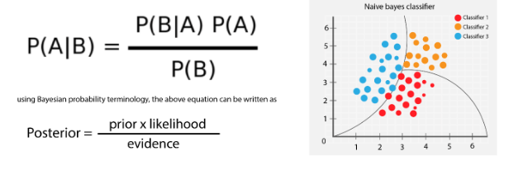

Bayes theorem provides a way of calculating posterior probability P(c|x) from P(c),

P(x) and P(x|c). Look at the equation below:

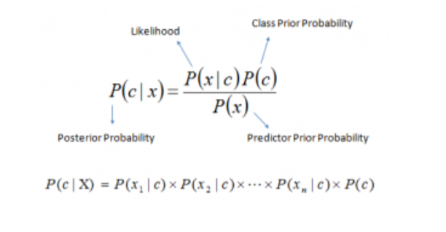

Above,

* P(c|x) is the posterior probability of class (c, target)

given predictor (x, attributes).

* P(c) is the prior probability of class.
* P(x|c) is the likelihood which is the probability of predictor given class.
* P(x) is the prior probability of predictor.

**Assumptions:**

The fundamental Naive Bayes assumption is that each feature makes an:

* Independent and
* equalcontribution to the outcome.

**How Naive Bayes algorithm works?**

Let us understand it using a simple example. Consider a fictional dataset thatdescribes the weather conditions for playing a game. Given theweatherconditions, each tuple classifies the conditions as fit (“Yes”) or unfit(“No”) for

playing.

Here is a tabular representation of our dataset.

|  |  |  |  |  |  |
| --- | --- | --- | --- | --- | --- |
| **Sr.NO** | **Outlook** | **Temperature** | **Humidity** | **Windy** | **Play** |

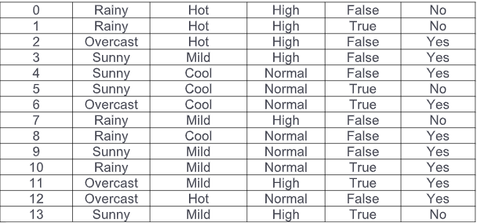

With relation to our dataset, the assumption for Naive Bayes’ can be.

understood as:

We assume that no pair of features are dependent. For example, the

temperature being ‘Hot’ has nothing to do with the humidity or the outlook.

being ‘Rainy’ has no effect on the winds. Hence, the features areassumed to be independent.

Secondly, each feature is given the same weight (or importance). For

example, knowing only temperature and humidity alone can’t predict the

outcome accurately. None of the attributes is irrelevant and assumed to be

contributing equally to the outcome.

Note: The assumptions made by Naive Bayes are not generally correct in

real-world situations. In-fact, the independence assumption is never correctbut often works well in practice.

Now, before moving to the formula for Naive Bayes, it is important to knowabout Bayes’ theorem.

Bayes’ Theorem finds the probability of an event occurring given the

probability of another event that has already occurred. Bayes’ theorem is

stated mathematically as the following equation:

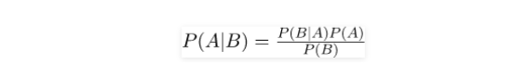

where A and B are events and P(B) ≠ 0.

Basically, we are trying to find probability of event A, given the event B is

true. Event B is also termed as evidence.

P(A) is the priori of A (the prior probability, i.e., Probability of event before

evidence is seen). The evidence is an attribute value of an unknown

instance (here, it is event B).

P (A|B) is a posteriori probability of B, i.e. probability of event after

evidence is seen.

Now, with regards to our dataset, we can apply Bayes’ theorem in following way:

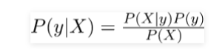

Where, y is class variable and X is a dependent feature vector (of size n)where:

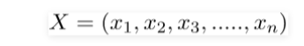

So basically, P(y|X) here means, the probability of “Not playing golf” given that the weather conditions are “Rainy outlook”, “Temperature is hot”,

“high humidity” and “no wind”.

Naive assumption

Now, its time to put a naive assumption to the Bayes’ theorem, whichis, independence among the features. So now, we split evidence into theindependent parts.

Now, if any two events A and B are independent, then,

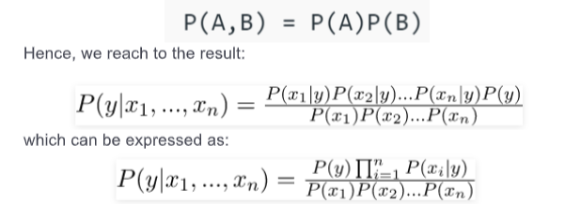

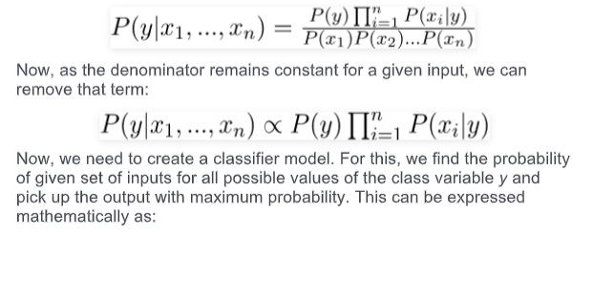

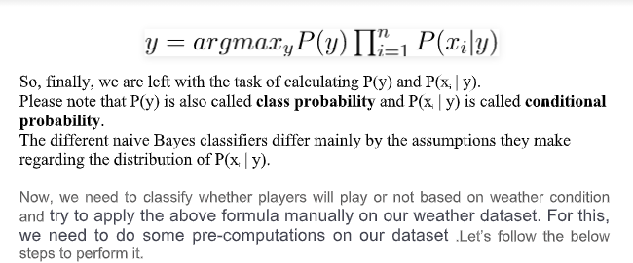

Step 1: Convert the data set into a frequency table.

Step 2: To create Likelihood table we need to find P(x i  | y j ) for each x i  in X and y j  iny.

Example: Probabilities like Overcast probability = 0.29 and probability of playing is

0.64. All these calculations have been demonstrated in the tables below:

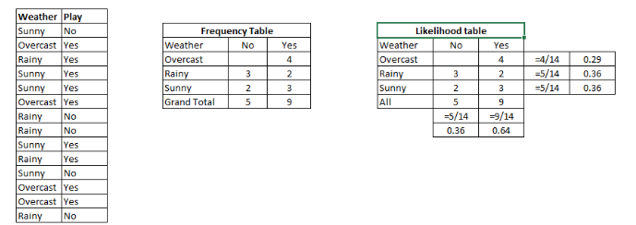

Step 3: Now, use Naive Bayesian equation to calculate the posterior probability foreachclass. The class with the highest posterior probability is the outcome of prediction.

**Advantages of Naïve Bayes:**

* It is easy and fast to predict class of test data set. It also performs well in multiclass prediction.
* When assumption of independence holds, a Naive Bayes learner and classifier’s perform better compare to other more sophisticated methods.
* Despite their apparently over-simplified assumptions, naive Bayesclassifiers have worked quite well in many real-world situations, famouslydocument classification and spam filtering. They require a small amount oftraining data to estimate the necessary parameters.
* It performs well in case of categorical input variables compared to numericalvariable(s). For numerical variable, normal distribution is assumed (bell curve,which is a strong assumption).

**Disadvantages of Naïve Bayes:**

* If categorical variable has a category (in test data set), which was not observed intraining data set, then model will assign a 0 (zero) probability and will be unableto make a prediction. This is often known as “Zero Frequency”. To solve this, wecan use the smoothing technique. One of the simplest smoothing techniques iscalled Laplace estimation.
* Another limitation of Naive Bayes is the assumption of independent predictors. Inreal life, it is almost impossible that we get a set of predictors which arecompletely independent

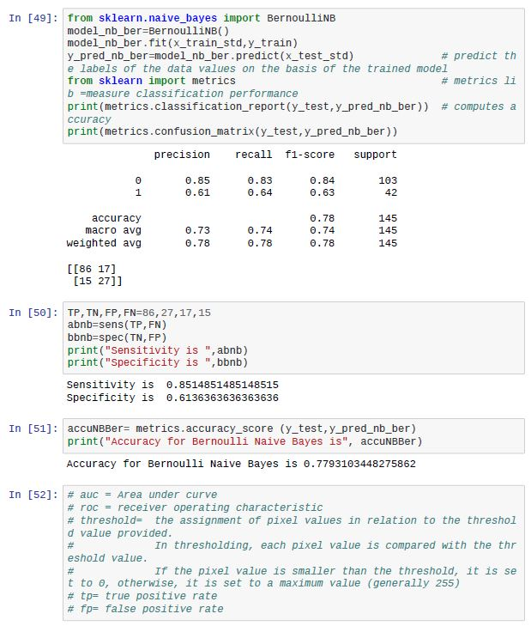

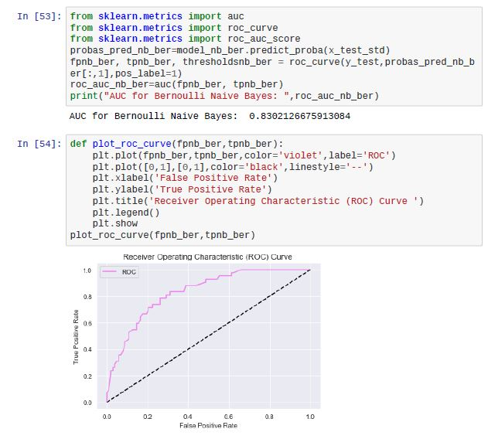

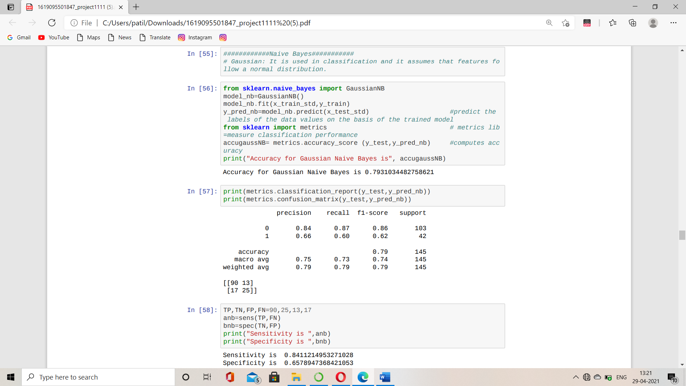

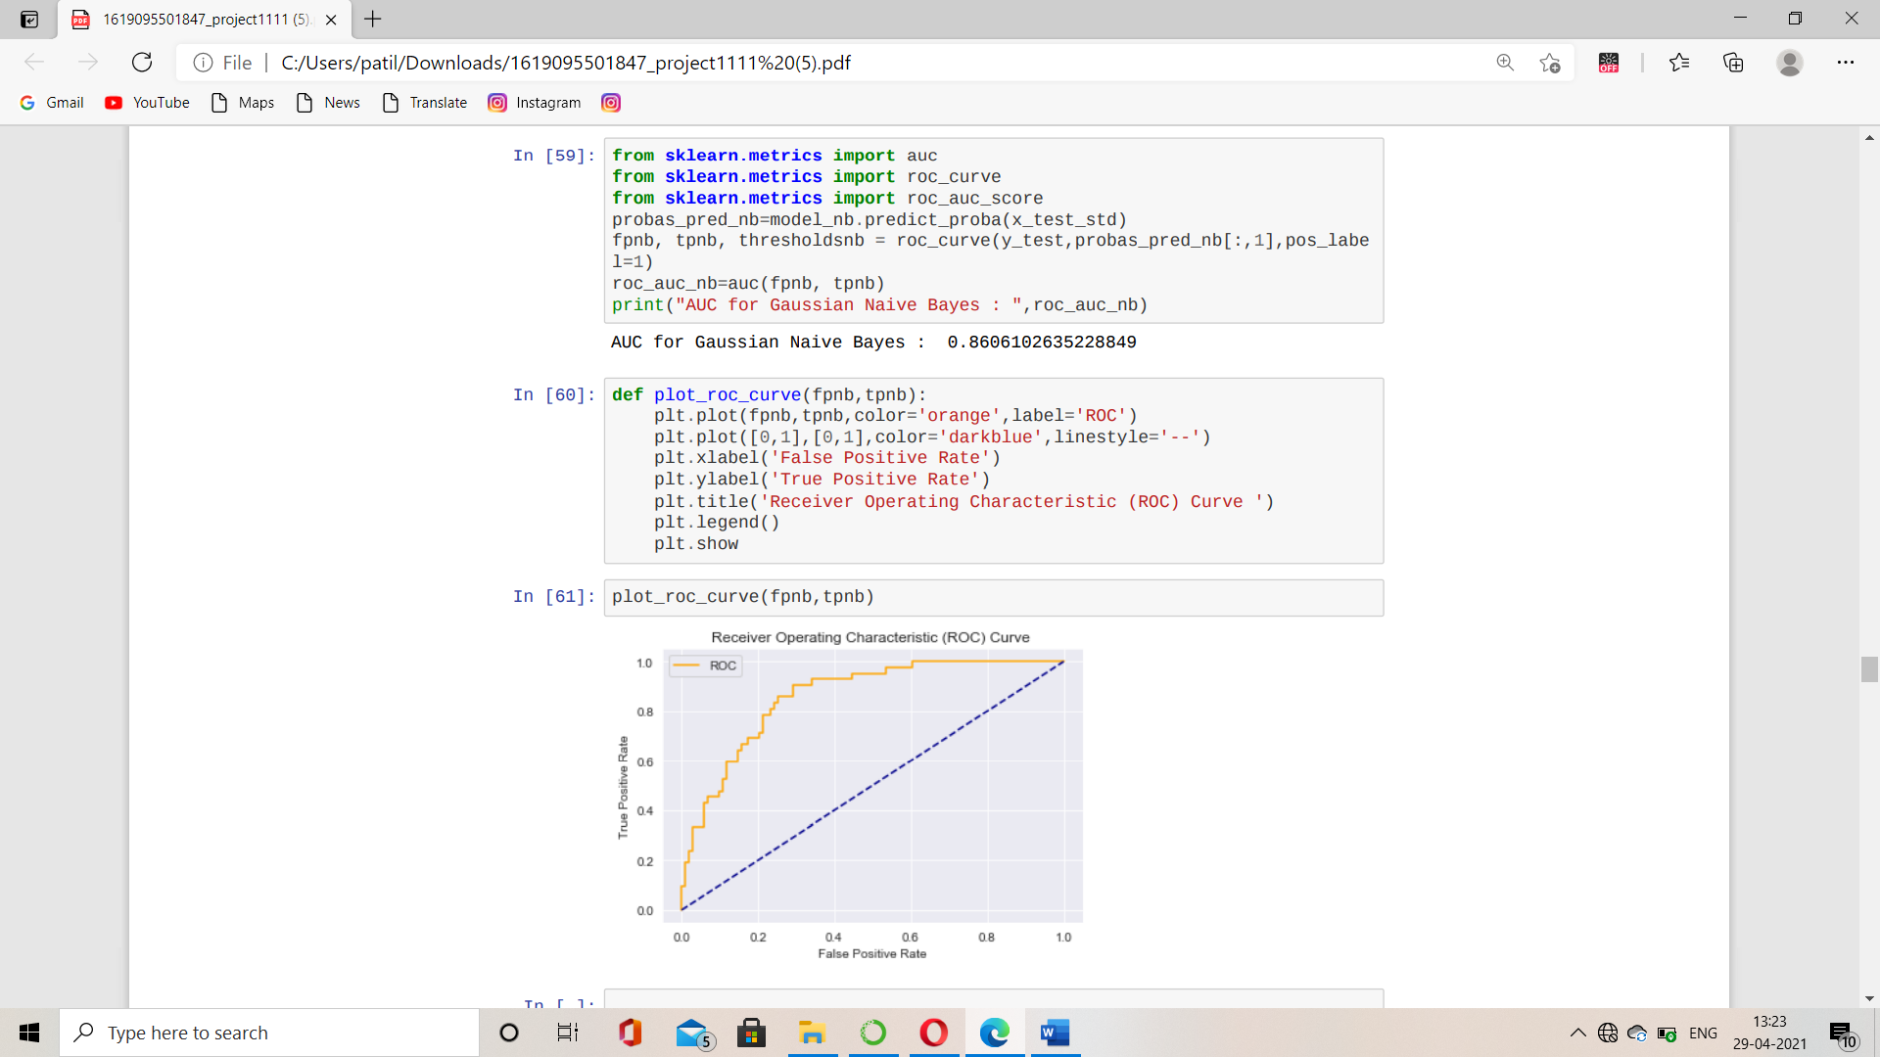

# 2.K-Nearest Neighbours (KNN)

K-Nearest Neighbour is one of the simplest Machine Learning algorithms based on Supervised Learning technique.

K-NN algorithm assumes the similarity between the new case/data and available cases and put the new case into the category that is most like the available categories.

K-NN algorithm stores all the available data and classifies a new data point based on the similarity. This means when new data appears then it can be easily classified into a well suite category by using K- NN algorithm.

K-NN algorithm can be used for Regression as well as for Classification but mostly it is used for the Classification problems.

**Example**: Suppose, we have an image of a creature that looks like cat and dog, but we want to know either it is a cat or dog. So, for this identification, we can use the KNN algorithm, as it works on a similarity measure. Our KNN model will find the similar features of the new data set to the cats and dogs’ images and based on the most similar features it will put it in either cat or dog category.

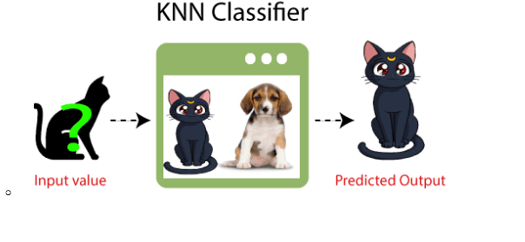

* **Features Of K-NN Algorithm**

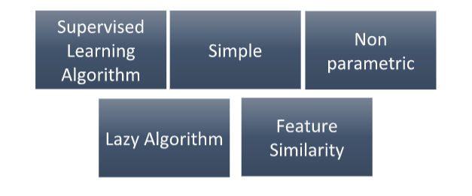

**Supervised Learning algorithmic**

Supervised learning is based on training data it labels and memorize the data intoclassified sets. Here in our data if we have 1 it is classified as diabetic patient and for 0, it is classified as healthy patient, that is what supervised algorithmstandsfor.

**Simple**

It works on amazingly simple concept, when you put in the new data it’s going to checkto which neighbour you are like, from two types of neighbour.

**Non-Parametric**

K-NN is a non-parametric algorithm, which means it does not make anyassumption on underlying data.

**Lazy Algorithm**

Here, Lazy means it does not learn the data it just memorizes the data, unlikeother parametric models where in you learn values, learn different predictions.

**Feature similarity**

KNN is based on feature similarity i.e., it is going to look around and look at thefeature and check how similar I am as compared to my neighbours.

* **How does K-NN algorithm works?**

Suppose there are two categories, i.e., Category A and Category B, and we have anew data point x1, so this data point will lie in which of these categories. To solvethis type of problem, we need a K-NN algorithm. We use Euclidean distanceformula to calculate distance between two points. With the help of K-NN, we caneasily identify the category or class of a particular dataset. Consider the below diagram:

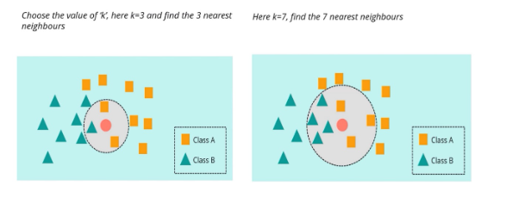

The K-NN working can be explained based on the below algorithm:

Step-1: Select the number K of the neighbours.

Step-2: Calculate the Euclidean distance of K number of neighbours.

Step-3: Take the K nearest neighbours as per the calculated Euclidean distance.

Step-4: Among these k neighbours, count the number of the data points in eachcategory.

Step-5: Assign the new data points to that category for which the number of the neighbour is maximum.

Step-6: Our model is ready.

**How to select the value of K in the K-NN Algorithm?**

To build the model, value of k needs to be chosen. Having k as an odd number ensures there are no ties, hence making the algorithm easier to implement. We perform 10fold cross validation to pick one among 20 values of k. Note that for KNN, the data must be normalized, i.e., cantered and scaled.

Below are some points to remember while selecting the value of K in the K-NNalgorithm:

There is no particular way to determine the best value for &quot; K&quot; so we need to trysome values to find the best out of them. The most preferred value for K is thevalue nearest to the square root of the number of observations.

An extremely low value for K such as K=1 or K=2, can be noisy and lead to the effectsof outliers in the model.

**Advantages of KNN Algorithm:**

It is simple to implement.

It is robust to the noisy training data.

It can be more effective if the training data is large.

**Disadvantages of KNN Algorithm:**

Always needs to determine the value of K which may be complex some time.

The computation cost is high because of calculating the distance between the data points for all the training samples.

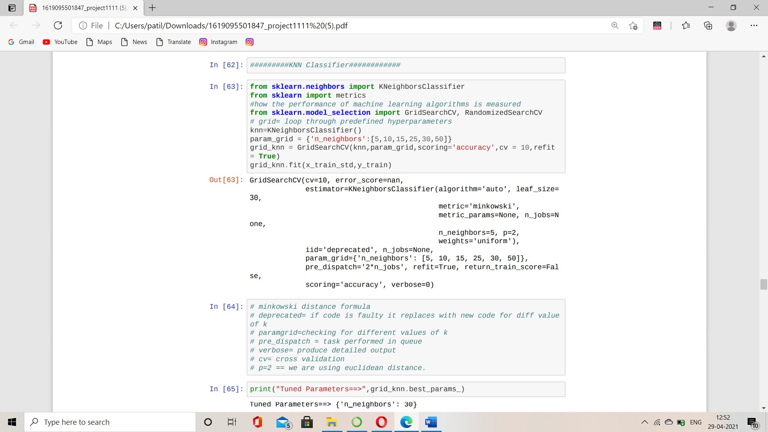

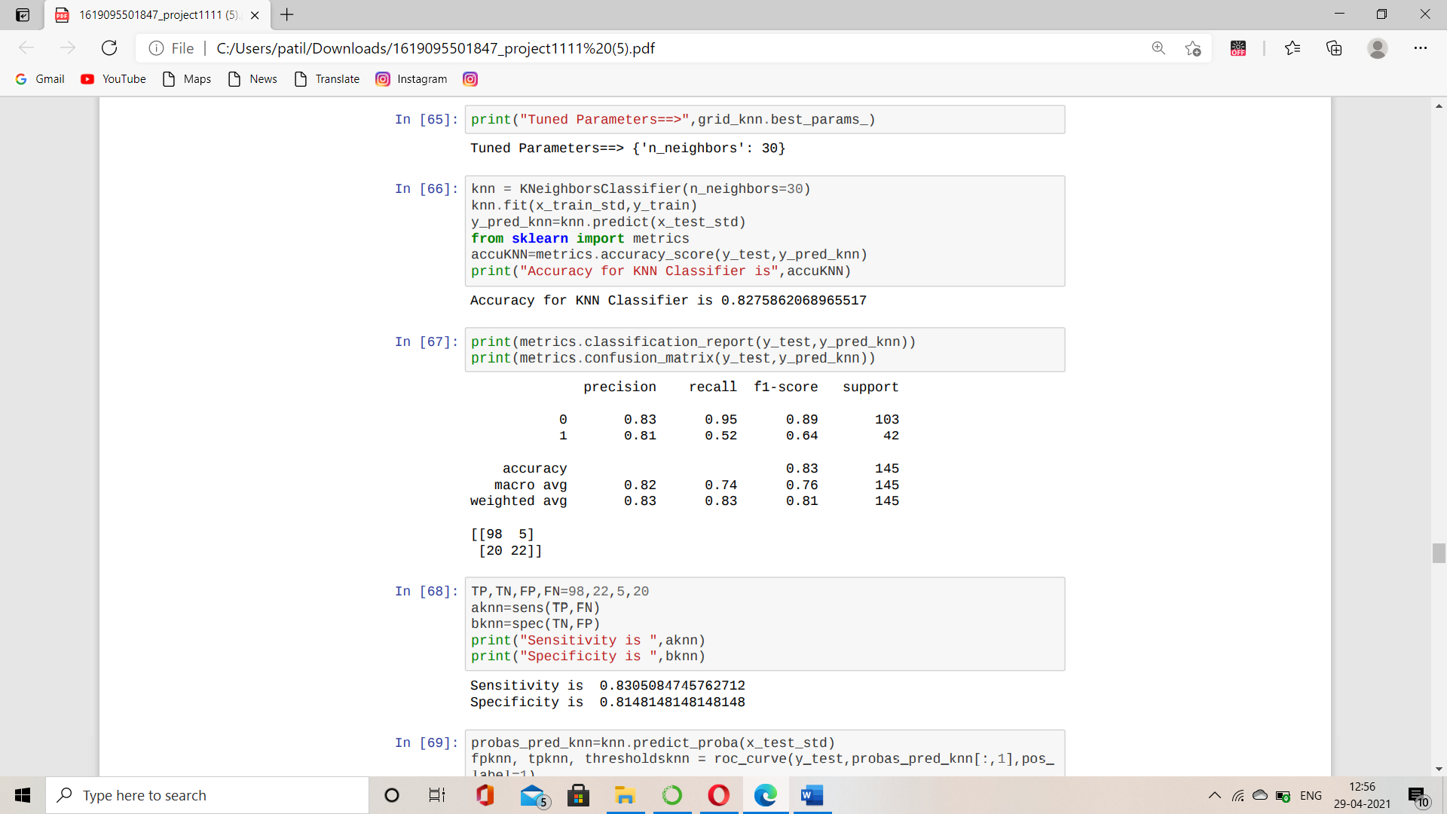

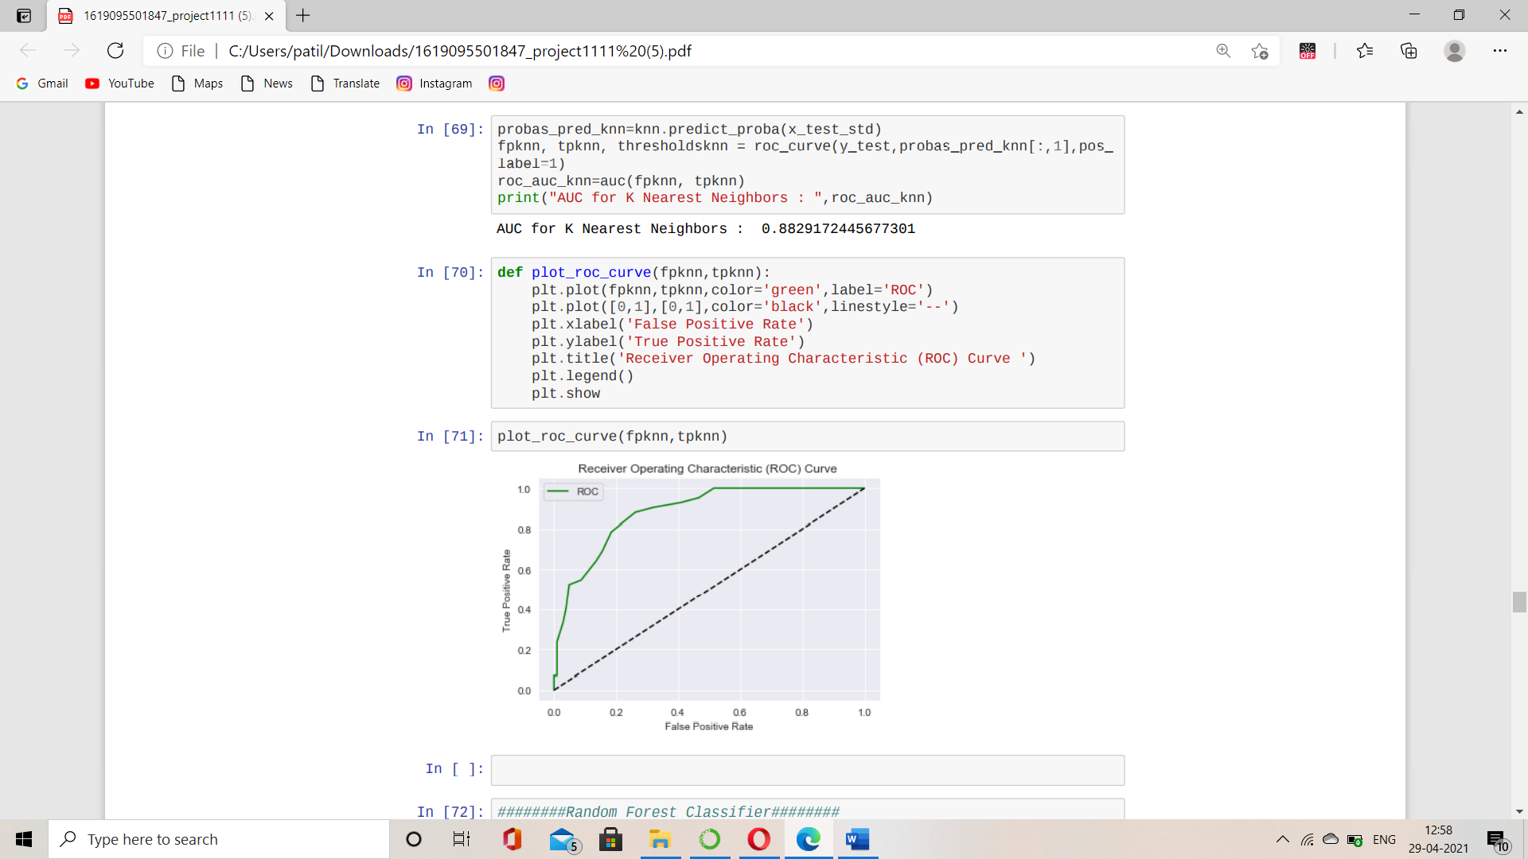

**3.RANDOM FOREST**

Random Forest is a popular machine learning algorithm that belongs tothe supervisedlearning technique. It can be used for both Classificationand Regression problems in ML. It is based on the concept of ensemblelearning, which is a process of combining multipleclassifiers to solve acomplex problem and to improve the performance of the model.Asthe name suggests, "Random Forest is a classifier that contains anumber of decisiontrees on various subsets of the given dataset andtakes the average to improve thepredictive accuracy of thatdataset." Instead of relying on one decision tree, the randomforest takesthe prediction from each tree and based on the majority votes ofpredictions, and it predicts the final output.The greater number of trees in the forest leads to higher accuracy andprevents the problem of overfitting.

**Why Random Forest and not Decision Tree?**

While random forest is a collection of decision trees, there are some differencesor example, to predict whether a person will click on an online advertisement, you mightcollect the ads the person clicked on in the past and some features that describe his/herdecision. If you put the features and labels into a decision tree, it will generate somerules that.help predict whether the advertisement will be clicked or not. In comparison,the randomforest algorithm randomly selects observations and features to build several decision treesand then averages the results.Another difference is "deep" decision trees might suffer from overfitting. Most of the time,random forest prevents this by creating random subsets of the features and building smallertrees using those subsets. Afterwards, it combines the subtrees. It's important to note thisdoesn’t work every time and it also makes the computation slower, depending on how many trees the random forest builds.

**Assumptions:**

Since the random forest combines multiple trees to predict the class ofthe dataset, it is possible that some decision trees may predict the correctoutput, while others may not. But together, all the trees predict thecorrect output. Therefore, below are two assumptions for a better Random Forest Classifier:

There should be some actual values in the feature variable of thedataset so that the classifier can predict accurate results rather thana guessed result.

The predictions from each tree must have extremely low correlations.

**Working of Random Forest:**

Random forest builds multiple decision trees and merges them together to get a more accurate and stable prediction.

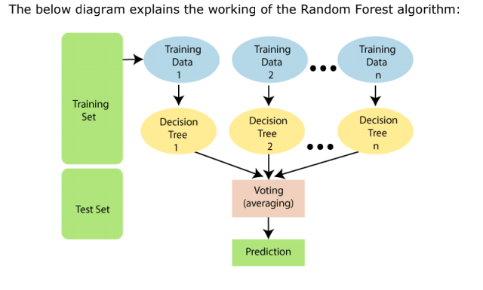

One big advantage of random forest is that it can be used for bothclassification and regression problems, which form the majority of currentmachine learning systems.

In Random Forest each tree is grown as follows:

1. If the number of cases in the training set is N, sample N cases at randombut with replacement, from the original data. This sample will be the trainingset for growing thetree.

2. If there are M input variables, a number m<<M is specified such that at eachnode, m variables are selected at random out of the M and the best split onthese m is used to split the node. The value of m is held constant during theforest growing.

3. Each tree is grown to the largest extent possible. There is no pruning.

**Advantages of Random Forest:**

• It can be used for both regression and classification tasks.

• It is also easy to view the relative importance it assigns to the input

features.

• Random forest is also a very handy algorithm.

**Disadvantages of Random Forest:**

• The main limitation of random forest is that many trees can

make the algorithm too slow and ineffective for real-time predictions.

• A more accurate prediction requires more trees, which results in aslower model.

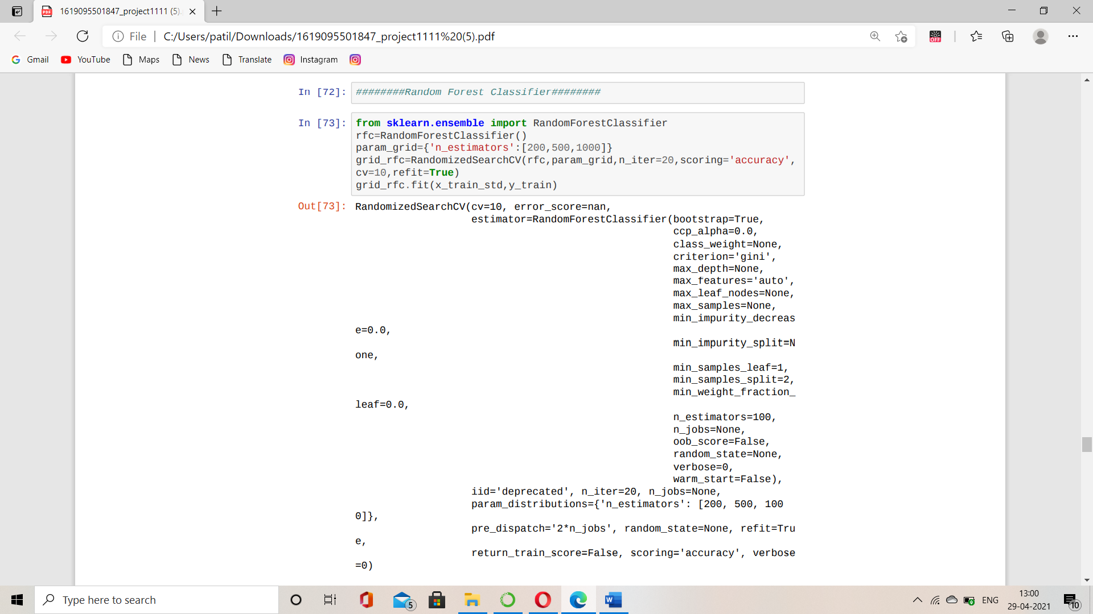

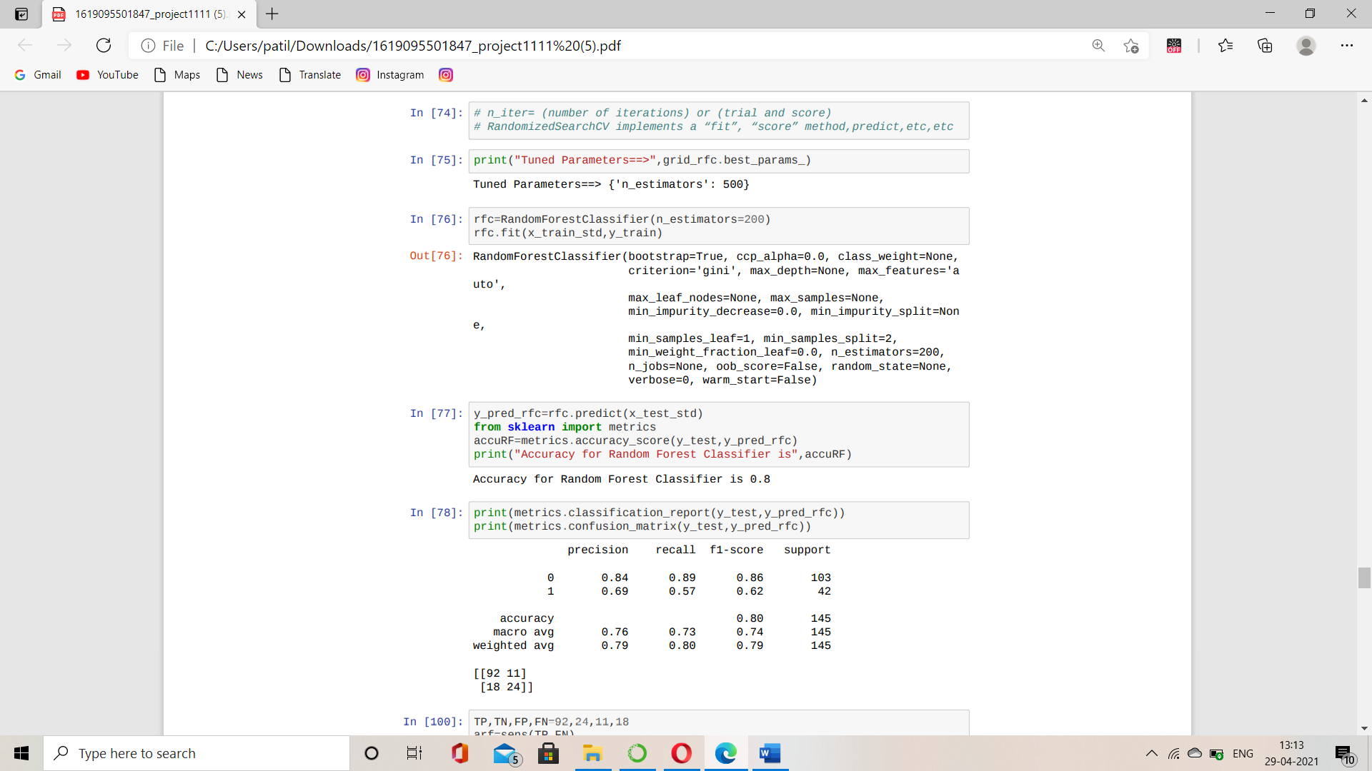

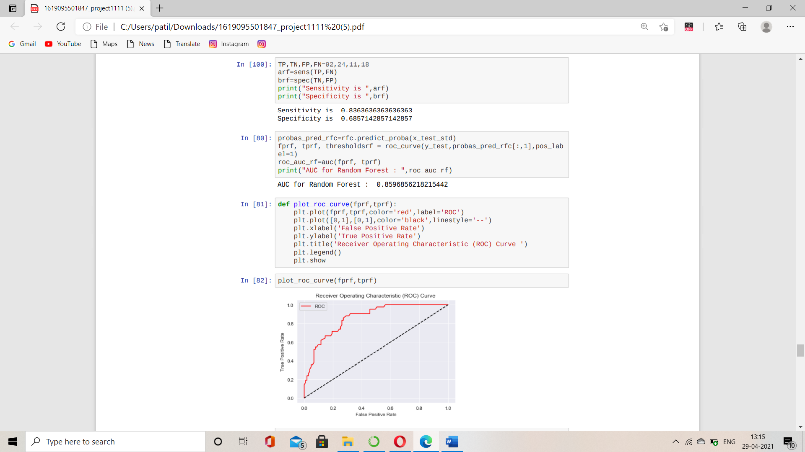

# 4.LOGISTIC REGRESSION

**What is Logistic Regression?**

Logistic regression is the regression which produces results in binary format and is used to predict the outcome of a categorical dependent variable. So, the outcome should be discrete/categorical for example, 0 or 1, yes or no, true or false, etc.

We must model p(X) using a function that gives outputs between 0 and 1 for all values of X. In logistic regression, we use the **logistic function.**

p(X)= 𝑒𝛽0+𝛽1𝑥 /1+𝑒𝛽0+𝛽1𝑥

i.e., Y=P(x)+∈ …………………… (1)

β0, β1 are the regression coefficients. A transformation of P(x) that is useful in the study of logistic regression is logit transformation.

**Logit transformation**=ln(P(X)/(1-P(X)) …………………… (2)

We see that the logistic regression model has a logit that is linear in X. Fitting of logistic regression model is done by maximum like hood estimation.

The logistic function will always produce an S-shaped curve of this form, and so regardless of the value of X, we will obtain a sensible prediction. We also see that the logistic model is better able to capture the range of probabilities. We find that,

p(X)/ [1 − p(X)] = 𝑒𝛽0+𝛽1𝑥 ………….……… (3)

The quantity p(X)/[1−p(X)] is called the **odds** and can take on any value odds between 0 and ∞. In a logistic regression model, increasing X by one unit changes the log odds by β1 or equivalently it multiplies the odds by e^(β1).

As the relationship between p(X) and X in is not a straight line, β1 does not correspond to the change in p(X) associated with a unit increase in X. The amount that p(X) changes due to a one-unit change in X will depend on the current value of X. But regardless of the value of X, if β1 is positive then increasing X will

associated with increasing p(X), and if β1 is negative then increasing X will be associated with decreasing p(X).

# Likelihood estimation

Method of maximum likelihood is used since it has better statistical properties. The basic idea behind using maximum likelihood to fit a logistic regression model is as follow we try to find β0 and β1 such that plugging these estimates into the model for p(X) gives a number close to one for all individuals who have heart disease and a number close to zero for all individuals who did not. This can be formalized using a mathematical equation called a likelihood function,

L (β0, β1) =i=1n∏ 𝑝(𝑥𝑖)*i=1n∏ [1 − 𝑝(𝑥𝑖)]

The estimates β0 and β1 are chosen to maximize this likelihood function.

We fit a logistic model to the train data.

**Assumptions:**

[Logistic regression](https://www.statisticssolutions.com/academic-solutions/membership-resources/member-profile/data-analysis-plan-templates/data-analysis-plan-logistic-regression/)does not make many of the key assumptions of [linear regression](https://www.statisticssolutions.com/academic-solutions/membership-resources/member-profile/data-analysis-plan-templates/data-analysis-plan-linear-regression/)and [general linear models](https://www.statisticssolutions.com/academic-solutions/resources/directory-of-statistical-analyses/generalized-linear-models/)that are based on ordinary least squares algorithms – particularly regarding linearity, normality, homoscedasticity, and measurement level.

**How come logistic and not linear?**

In linear regression, the dependent variable ranges from whichdoesn't provides us actual view of categorical classification. But in logisticregression, as the dependent variable can only bear discrete binary values (0 0r1), it gives the broader view of categorical classification and helps us in prediction.

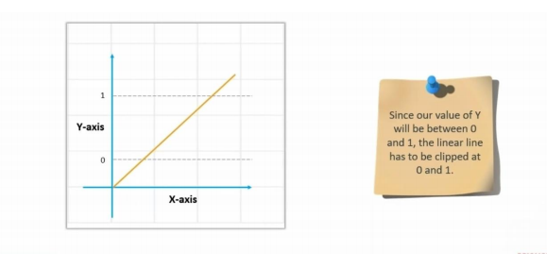

The above graph provides us the straight-line curve of linear regression in which the dependent variable Y could take values ranging from depending upon values of X. But our motive is to obtain outcome in binary format; hence we haveto clipped values at 0 and 1.The next graph gives us idea how graph looks after clipping at 0 and 1.

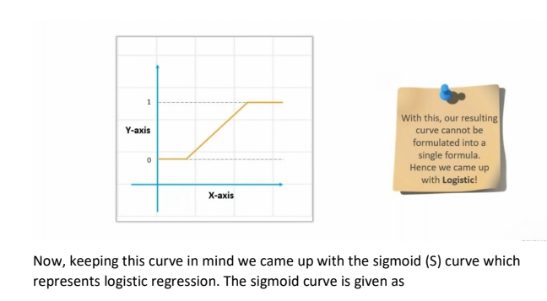

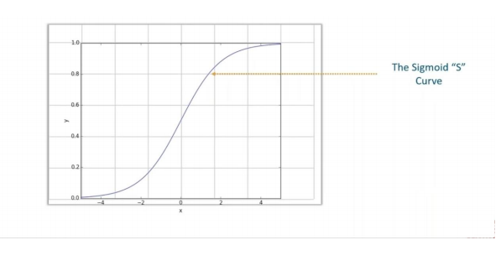

**How Logistic works?**

But one cannot decide the outcome as 0 or 1 by means of probabilities indecimals. Hence, we’ve to decide threshold for above curve which will give us theclear classification between outcomes.Threshold probability acts as a barrier which classifies the outcomes in intowinning (1) or losing (0) categories. Considering threshold as 0.5our graph looks like,

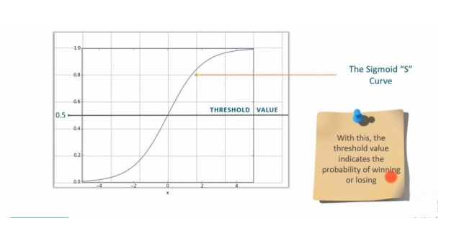

**Advantages and Disadvantages:**

* **Advantages**

1. Logistic regression is easier to implement, interpret, and very efficient to train.
2. It makes no assumptions about distributions of classes in feature space.
3. It can easily extend to multiple classes (multinomial regression) and a natural probabilistic view of class predictions.

* **Disadvantages**

1. If the number of observations is lesser than the number of features, Logistic Regression should not be used, otherwise, it may lead to overfitting.
2. It constructs linear boundaries.
3. The major limitation of Logistic Regression is the assumption of linearity between the dependent variable and the independent variables.

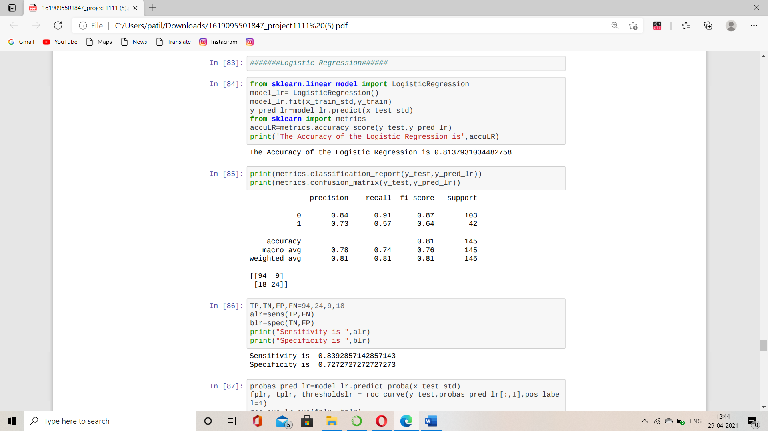

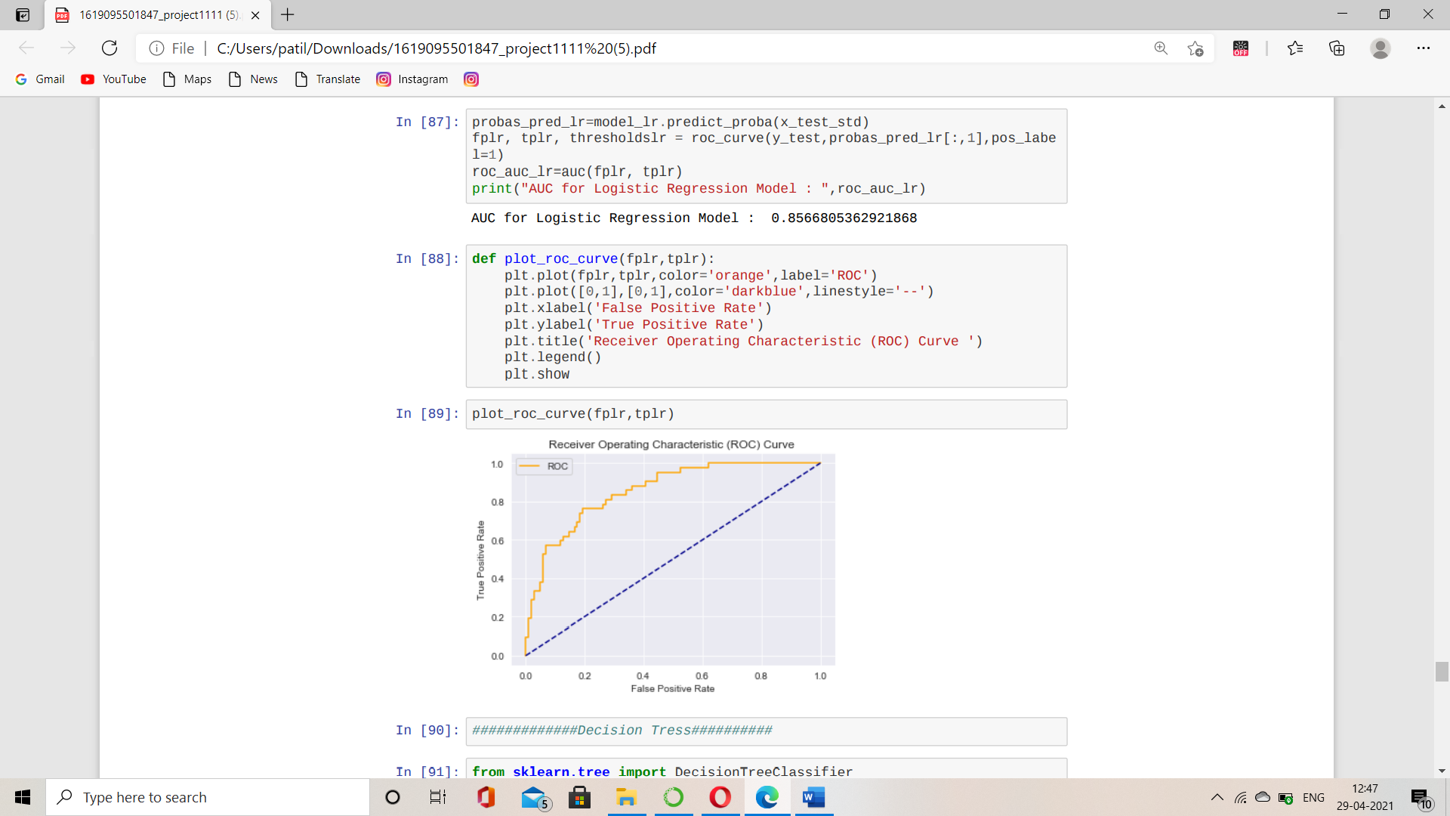

**5. Classification and Regression Trees:**

**What is Decision Tree?**

A decision tree is a decision support tool that uses a tree-like model of decisions and their possible consequences, including chance event outcomes, resource costs, and utility. It is one way to display an algorithm that only contains conditional control statements. Classification and Regression Trees or CART for short is a term introduced by Leo Bierman to refer to Decision Tree algorithms that can be used for classification or regression predictive modeling problems. Classically, this algorithm is referred to as “decision trees”, but on some platforms like R they are referred to by the more modern term CART. The CART algorithm provides a foundation for important algorithms like bagged decision trees, random forest and boosted decision trees.

## Terminology of Regression Trees

As stated, earlier Decision tree is a supervised learning algorithm. It classifies instances by sorting them down the tree from the root to some leaf node, which provides the classification of the instance. It is tree like structure starts with the root node at the top, the root node, where the process of decision-making starts. Under the Root nodes are Interior nodes or simply known as decision nodes. They can have two or more branches as per needed. Lastly comes the Leaf nodes which represents the classification or decision of the instance. This node has no additional nodes coming off them.

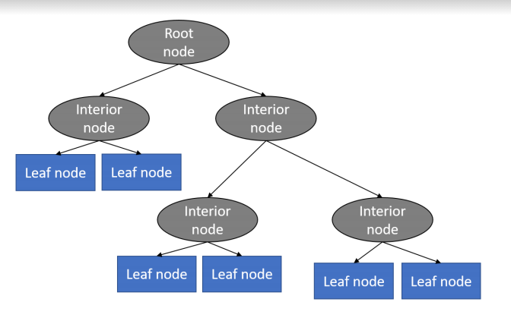

**Root:** This is the beginning of decision tree, which also represents the population sample. For example, say you want to decide the best performing employee in an organization based on various criteria, such as attendance of the employee, number of successful projects, number of employees he/she mentored, etc. So here, the entire population of employees is at the root of the decision tree. **Leaf:** The terminal node is called the leaf node. In our example, the final best employee would be the leaf node or the terminal node.

**Decision Node:** Here the other nodes are divided into the further categories. In our example, the various criteria would determine a decision node.

**Child Node:** When a node is divided into other subparts, subparts are called child nodes. And the node which is divided is called the **parent node.**

**Construction of Decision Tree:**

A tree can be “learned” by splitting the source set into subsets based on an attributevalue test. This process is repeated on each derived subset in a recursive mannercalled recursive partitioning. The recursion is completed when the subset at a node allhas the same value of the target variable, or when splitting no longer adds value tothe predictions. The construction of decision tree classifier does not require anydomain knowledge or parameter setting, and therefore is appropriate for exploratoryknowledge discovery. Decision trees can handle high dimensional data. In generaldecision tree classifier has good accuracy. Decision tree induction is a typical inductiveapproach to learn knowledge on classification.

**Advantages of regression trees:**

* A user can visualize each step, which can help with making rational decisions.
* You can give the priority to a decision criterion. For example, in our employee example, you can put the attendance criteria on the top of the decision tree if that is the most important criteria.
* Making a decision based on regression is much easier than most other methods. Since most of the undesired data will be filtered outlier each step, you must work on less data as you go further in the tree.
* It is easy to prepare a regression tree. A user can present it to the higher authorities in a much easier way as it can be represented on a simple chart or diagram.

**Disadvantages of regression trees:**

* Decision trees are less appropriate for estimation tasks where the goal is to

predict the value of a continuous attribute.

* Decision trees are prone to errors in classification problems with many classand relatively small number of training examples.
* Decision tree can be computationally expensive to train. The process of

growing a decision tree is computationally expensive. At each node, each

candidate splitting field must be sorted before its best split can be found. In

some algorithms, combinations of fields are used, and a search must be.

made for optimal combining weights. Pruning algorithms can also be.

expensive since many candidate sub-trees must be formed and compared.

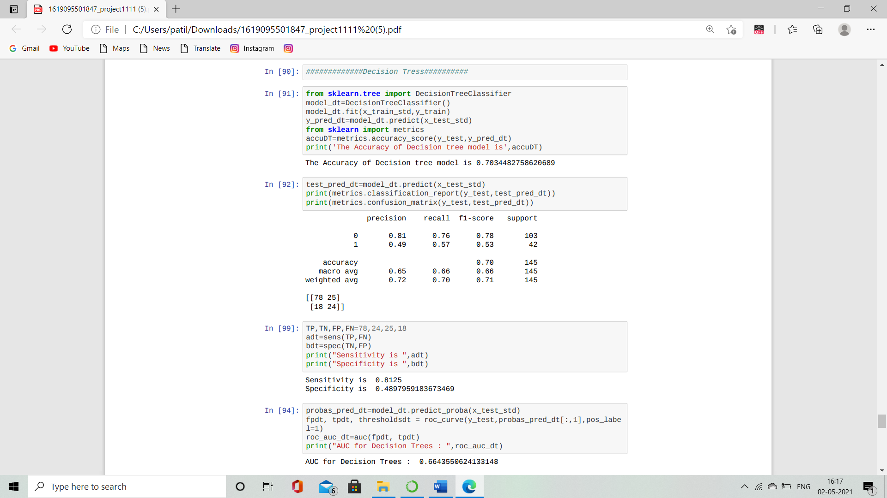

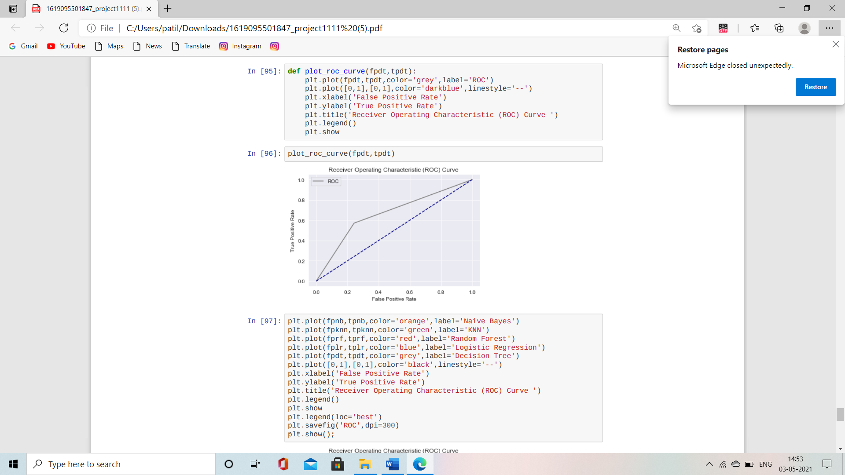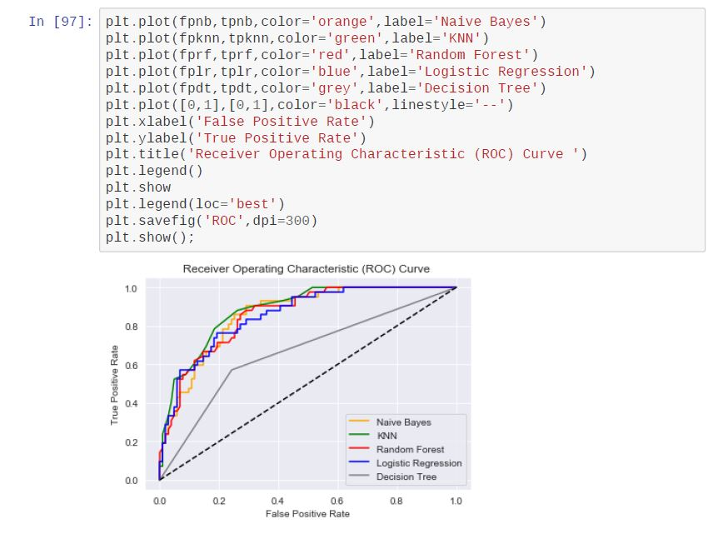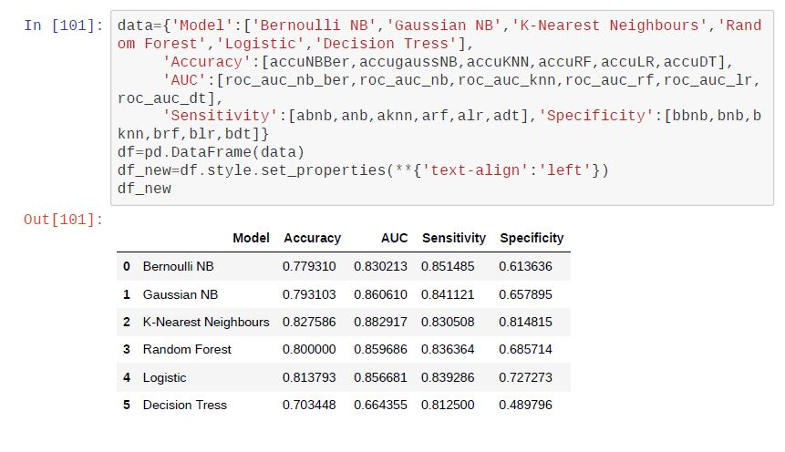

**Conclusion**

As we can see from the above comparison ,K-NN(K- Nearest Neighbours) is the best classifier for the following data, i.e. from 4 of those variables K-NN shows the highest score for ***Accuracy, AUC, Specificity.***

**Scope of the project:**

As the risks of occurring diabetes are developing day by day and diabetes is not curable disease, so the project gives an idea to control the diabetes based on different predictors. The project can help to predict the accuracy of different statistical models and comparative study of them.

The scope of the project thus goes as far as one can take it through the help of statistical tools and several models.

**References**

This project would have been impossible without Josh Starmer from Stat Quest and Krish Naik on YouTube.Their tutorials on machine learning techniques helped clear our basics ,enabling us to take up this project.

[www.cdc.gov/diabetes/basics/gestational.html](https://www.cdc.gov/diabetes/basics/gestational.html)<https://youtube.be/HVXime0nQel><https://youtube/IDCWX6vCLFA>



[www.kaggle.com/uciml/pima-indians-diabetes-database](http://www.kaggle.com/uciml/pima-indians-diabetes-database)

<https://en.m.wikipedia.org/wiki/Naive-Bayes-classifier>

* <https://www.analyticsvidhya.com/blog2017/09/naive-bayes-explained/>
* <https://www.geeksforgeeks.org/naive-bayes-classifier>
* <https://medium.com/@srishtisawla/introduction-to-naive-bayes-for-classification-baefefb43a2d>
* <https://towardsdatascience.com/pima-indian-diabetes-prediction-7573698bd5fe>
* <https://www.biorxiv.org/content/10.1101/643833v2.full>
* <https://www.analyticsvidhya.com/blog/202006/auc-roc-curve-machine-learning>
* <https://youtu.be/XSoau-q0kz8>
* <https://youtu.be/lDCWX6vCLFA>